Macroeconomics — Quantitative Finance
Growth, Inflation, Rates and Currencies: the Mathematics of the Macro Environment
From GDP Accounting and the Yield Curve to VARs, Kalman Filters and Regime Models
A companion module in the Quantitative Finance Curriculum — beginner to advanced
Covers: GDP and the business cycle · inflation and the Phillips curve · central banks and the Taylor rule · yield curve, duration and convexity · Nelson–Siegel · fiscal policy and IS–LM · exchange rates, parity conditions and carry · valuation and equity risk premium · growth–inflation regimes · macro factor models · event studies · stock–bond correlation · stationarity and unit roots · VARs and impulse responses · cointegration · local projections · Kalman filter and nowcasting · Markov-switching regimes · New-Keynesian model · real-time data and backtesting · macro strategies
Table of Contents
How to Use This Guide
What You Need to Know Before Starting
Understand Before Proceeding
Why It Matters
How This Connects to the Rest of the Curriculum
Glossary of Recurring Terms
Part 1 — The Macro Landscape: Output, Growth and the Business Cycle
1.1 GDP and the Expenditure Identity
1.2 Nominal versus Real, and Growth Rates
1.3 The Business Cycle
1.4 The Labour Market and Okun's Law
1.5 The Data Calendar: What Gets Released and When
Part 2 — Inflation, Money and Central Banks
2.1 Measuring Inflation
2.2 Where Inflation Comes From: Demand, Supply and Expectations
2.3 Central Banks: Tools and Transmission
2.4 The Taylor Rule and Reaction Functions
2.5 Reading the Market's Expectation of Policy
Part 3 — Interest Rates and the Yield Curve
3.1 Nominal Rates, Real Rates and Inflation Compensation
3.2 Bond Mathematics: Price, Duration and Convexity
3.3 The Yield Curve: Shapes, Forwards and the Term Premium
3.4 Modelling the Curve: Nelson–Siegel and Principal Components
3.5 The Curve and the Cycle: Signals and Trades
Part 4 — Fiscal Policy, Aggregate Demand and Open Economies
4.1 Fiscal Policy, Multipliers and Debt Dynamics
4.2 The Balance of Payments and Exchange Rates
4.3 The Currency Carry Trade
4.4 Capital Mobility, Exchange-Rate Regimes and the Trilemma
Part 5 — Macro and Asset Prices
5.1 Valuation, Discount Rates and the Equity Risk Premium
5.2 Growth and Inflation Regimes
5.3 Macro Factor Models and Risk Premia
5.4 Event Studies: Measuring the Reaction to Surprises
5.5 Stock–Bond Correlation as a Macro Variable
Part 6 — Time-Series Econometrics for Macro Data
6.1 Stationarity, Autoregressions and Unit Roots
6.2 ARMA Models, Forecasting and Forecast Evaluation
6.3 Vector Autoregressions and Impulse Responses
6.4 Cointegration and Error-Correction
6.5 Local Projections and Identification
Part 7 — State-Space Models, Regimes and Structural Macro
7.1 State-Space Models and the Kalman Filter
7.2 Nowcasting
7.3 Markov-Switching Regime Models
7.4 Structural Models: The New-Keynesian Framework (Awareness)
Part 8 — From Macro Models to Macro Strategies
8.1 Real-Time Data, Revisions and Look-Ahead Bias
8.2 Why Macro Backtests Fail: A Checklist
8.3 Building a Macro Signal and Turning It into a Position
8.4 Families of Macro Strategies
Practical Exercise
Suggested approach
Common Beginner Mistakes
Advanced Extensions
Professional Applications
Where to Go Next
Appendix A — Formula Sheet
Appendix B — Self-Check Questions

How to Use This Guide
This document is a companion to Macroeconomics — Quantitative Finance, the module that explains the economy-wide forces that move every market a quantitative investor trades. Where the Optimisation module turns estimates into portfolios, this module explains where many of those estimates come from: growth, inflation, interest rates, currencies, and the policy decisions that drive them. Every other asset class eventually answers to the same handful of macro variables.
The guide is built to be read from beginner to advanced. It starts from what GDP and inflation actually measure, and builds step by step to yield-curve factor models, vector autoregressions, Kalman-filter nowcasting, Markov regime-switching, and a New-Keynesian model. Each concept is introduced from first principles, paired with a worked numerical example, and illustrated with a chart or diagram. Every section carries a level tag so you can plan a route through it.
Table 0.1 — Suggested learning paths
If you are… | Read | Skim or skip
New to economics and finance | Parts 1–3 fully, then Part 5 (5.1–5.2); the Glossary and Common Beginner Mistakes | The Intermediate and Advanced tagged sections on first read
A quant with a statistics background but little macro | Parts 1–5 quickly for vocabulary; Parts 6–8 carefully | Beginner derivations such as GDP accounting
A practitioner building macro signals | Parts 5, 6, 7 and 8, then the Practical Exercise | Part 1; revisit Part 3 for curve trades
Preparing for an interview | Appendix A (formula sheet), Appendix B (self-check questions), worked-example boxes | Code skeletons

Level tags. Each numbered section starts with a tag. Beginner needs only arithmetic and the prerequisites below. Intermediate uses regression, matrices, and basic time-series ideas. Advanced uses state-space and regime models, or assumes you have met the Intermediate material. Advanced sections are deliberately introduced at awareness-to-working depth — enough to reason correctly and read the literature, not enough to run a production macro desk.
All data in the charts of this document are simulated or stylised to illustrate a mechanism. None of them is a historical record, and the numerical examples use round figures chosen to make the arithmetic easy to follow. Where a statement describes how markets or economies usually behave, it is a tendency, not a law.

What You Need to Know Before Starting
- Algebra and basic calculus — compounding, exponents and logarithms, and the idea of a derivative as a rate of change (used for duration and for comparative statics).
- Probability and statistics — mean, variance, covariance, correlation, and the intuition for a regression coefficient and its standard error.
- Linear algebra (for Parts 6–7) — vectors, matrices, eigenvalues, and matrix multiplication; a VAR and a Kalman filter are both written in matrix form.
- Finance basics — what a bond, a stock, and a currency pair are; what a yield is; and what the Sharpe ratio measures.
- Some programming — the exercises use Python with NumPy, pandas, and statsmodels, but no step requires more than reading and writing arrays and data frames.

Understand Before Proceeding
Prerequisite gate — Macro is a story about few data points, not a lot of data.
A quantitative equity strategy might have thousands of stocks and millions of daily observations. A macro strategy has, at best, a few hundred monthly observations of each variable, and a dozen or so US recessions since the Second World War. The data are low-frequency, heavily revised after release, and generated by an economy whose structure changes with policy regimes — so relationships estimated in one era routinely weaken or flip sign in the next.
This changes how the quantitative tools are used. A model that fits the past beautifully is a weak guide to the future if it is calibrated on a handful of independent episodes. Throughout this document the emphasis is on simple, economically motivated models, honest out-of-sample testing, and point-in-time data. The Advanced topics (state-space, regime-switching, structural models) are treated at awareness-to-working depth; they are powerful, and also the easiest to over-fit.

Why It Matters
Macroeconomics matters to a quant for three reasons. First, macro variables are the common drivers of asset returns. Equity indices, bond yields, credit spreads, currencies, and commodities all react to the same news: growth surprises, inflation surprises, and central-bank decisions. Understanding these drivers is how you understand why correlations between asset classes shift over time.
Second, macro supplies the discount rate. Every asset is a stream of cash flows discounted at an interest rate. The level and shape of the yield curve, and what central banks do to it, set the price of nearly everything. A one-percentage-point rise in the discount rate cuts the price of a long-duration bond or growth stock far more than a one-percentage-point change in next quarter's earnings.
Third, macro defines regimes. A strategy's performance depends strongly on whether the economy is in an inflationary boom, a disinflationary slump, or a stagflationary squeeze. Quants who ignore regime dependence discover it in drawdowns. Those who model it explicitly can scale risk, hedge more intelligently, and avoid mistaking a regime effect for alpha.
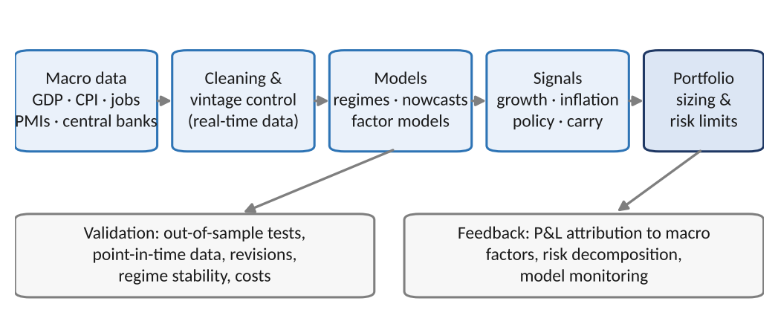
Figure 0.1 — Where macroeconomics sits in the quantitative investment process: data are cleaned and time-stamped, turned into model outputs and signals, and sized into a portfolio, with validation and monitoring feeding back at every stage.

How This Connects to the Rest of the Curriculum
- Research — Macro models supply factor exposures, regime indicators, and expected-return inputs. They also supply the economic hypotheses that disciplined research tests: a signal with a clear macro rationale is far less likely to be a data-mining artefact.
- Optimisation — The mean-variance, risk-parity, and robust-optimisation machinery of the Optimisation module needs expected returns and covariances. Macro regimes are one of the best-motivated ways to make those inputs time-varying (Part 5 and Part 7 return to this).
- Risk Metrics — Interest-rate duration, convexity, and DV01 (Part 3) are the building blocks of rate-risk measurement. Regime-conditional volatility (Part 7) feeds directly into VaR and stress testing.
- Development — Real-time data handling (Part 8) is a data-engineering problem: vintage storage, release-date alignment, and reproducible backtests are infrastructure, not an afterthought.
- Trading — Global macro, rates relative value, FX carry, and inflation trading (Part 8) all rest directly on the material here, as do the event-driven reactions to scheduled releases.

Glossary of Recurring Terms
Gross Domestic Product (GDP) — The market value of all final goods and services produced within an economy in a period.
Output gap — The percentage difference between actual output and potential (non-inflationary) output; positive when the economy runs hot.
Inflation (π) — The percentage rate of increase in a broad price level over time, usually measured year-on-year.
Real vs nominal — Nominal values are in current prices; real values are adjusted for inflation to reflect purchasing power.
Policy rate — The short-term interest rate a central bank directly controls, such as the federal funds rate.
Neutral rate (r*) — The real interest rate consistent with output at potential and stable inflation; neither stimulative nor restrictive.
Yield curve — The relationship between yields and maturities of otherwise similar bonds.
Term premium — The extra yield investors demand for holding a long-maturity bond rather than rolling short-term bonds.
Duration — The sensitivity of a bond's price to a change in its yield; approximately the percentage price change per 1% yield move.
Breakeven inflation — The difference between a nominal bond yield and an inflation-linked bond yield of the same maturity; the market's inflation compensation.
Phillips curve — The empirical relationship between slack in the economy (e.g., unemployment) and inflation.
Taylor rule — A rule of thumb prescribing the policy rate as a function of inflation and the output gap.
Carry — The return from holding an asset if prices do not change: the interest differential in currencies, the roll-down and coupon in bonds.
Stationarity — A time series whose statistical properties (mean, variance, autocorrelation) do not change over time.
Unit root — A feature of non-stationary series in which shocks have permanent effects, as in a random walk.
Cointegration — A long-run equilibrium relationship between non-stationary series: a combination of them is stationary.
VAR / impulse response — A system of regressions in which each variable depends on lags of all variables; an impulse response traces the effect of a one-time shock.
Kalman filter — A recursive algorithm that estimates an unobserved state (e.g., latent growth) from noisy observations.
Regime switching — A model in which parameters change according to an unobserved Markov state, such as 'calm' versus 'stress'.
Nowcasting — Estimating the current (not-yet-published) value of a macro variable from timely indicators.
Vintage / real-time data — The data exactly as they were published on a given date, before later revisions.
Macro surprise — The difference between a released figure and the consensus forecast; the unexpected component that moves markets.

Part 1 — The Macro Landscape: Output, Growth and the Business Cycle
Macroeconomics studies the economy as a whole: total output, total employment, the general price level, and the interest and exchange rates that connect them. This part builds the vocabulary and the accounting. It covers how output is measured, how to separate real growth from price changes, what the business cycle is and how analysts detect its turning points, and which data releases carry the information.

1.1 GDP and the Expenditure Identity
Level: Beginner
Gross Domestic Product (GDP) is the market value of all final goods and services produced in an economy in a given period. 'Final' avoids double-counting: the steel inside a car is counted once, in the price of the car. GDP can be measured three ways that must agree in principle: by expenditure (who buys the output), by income (who earns it as wages, profits, and rents), and by production (value added at each stage). Quant work mostly uses the expenditure view:
Y = C + I + G + (X − M)
Here C is household consumption, I is investment (business capital spending, housing, and inventories), G is government purchases of goods and services (not transfer payments), X is exports, and M is imports. Net exports NX = X − M is the trade balance. Because each component responds to different drivers — consumption to income and confidence, investment to interest rates and expected profits, government spending to policy, net exports to exchange rates and foreign demand — the decomposition tells you where a slowdown or boom comes from.
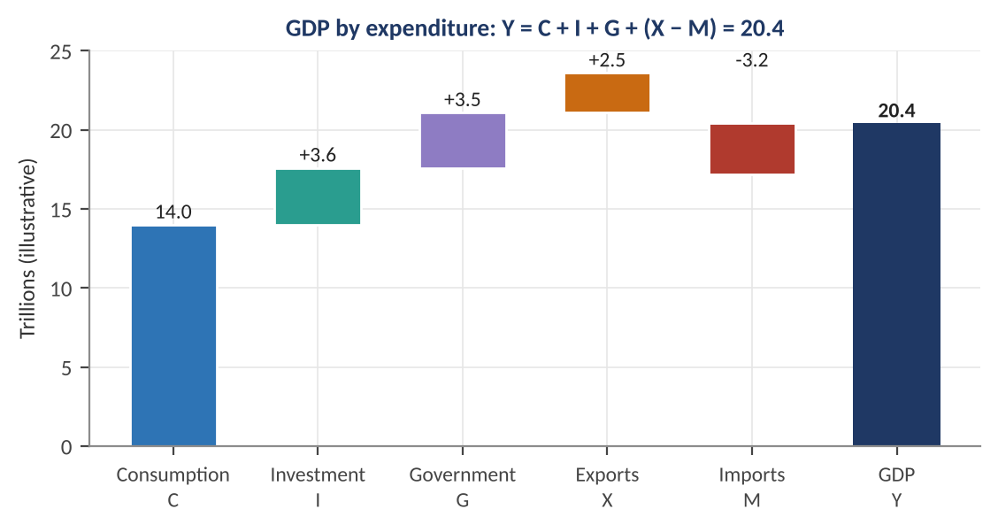
Figure 1.1 — GDP by expenditure for an illustrative economy (trillions of currency units). Consumption dominates, which is why consumer behaviour is the single most watched driver of the cycle; imports are subtracted because they are produced abroad.
Worked example — Reading a GDP report.
An economy has C = 14.0, I = 3.6, G = 3.5, X = 2.5 and M = 3.2 (trillions). GDP = 14.0 + 3.6 + 3.5 + (2.5 − 3.2) = 20.4. Consumption is 14.0 / 20.4 = 68.6% of GDP. Suppose next year C rises 3%, I falls 5%, and the other components are unchanged. New C = 14.42 and I = 3.42, so Y = 14.42 + 3.42 + 3.5 − 0.7 = 20.64, a nominal rise of 1.18%. The drop in investment (−0.18) offsets about 43% of the consumption gain (+0.42), which is why a small fall in a volatile component can dominate the headline.

Growth accounting: where does growth come from?
Over long horizons, output growth comes from more inputs and from better use of them. A standard decomposition, derived from a Cobb–Douglas production function Y = A·Kᵅ·L¹⁻ᵅ, is:
g_{Y} = α · g_{K} + (1 − α) · g_{L} + g_{A}
Here g denotes a growth rate, K is capital, L is labour, α is capital's share of income (about 0.3–0.4 in many advanced economies), and A is total factor productivity (TFP), the part of growth that is not explained by more capital or labour. TFP is computed as a residual, so it absorbs measurement error as well as genuine technology gains.
Worked example — Growth accounting.
Suppose output grows 3.0% a year, capital 3.0%, and labour 1.0%, with α = 0.35. Capital contributes 0.35 × 3.0 = 1.05 points and labour 0.65 × 1.0 = 0.65 points. TFP growth is the residual: 3.0 − 1.05 − 0.65 = 1.30%. If labour-force growth slows to 0% because of ageing, trend growth falls by 0.65 points unless productivity rises to compensate — the arithmetic behind the debate on slower long-run growth and lower neutral interest rates.

1.2 Nominal versus Real, and Growth Rates
Level: Beginner
A rise in nominal GDP may reflect more output, higher prices, or both. Real GDP removes price changes by valuing output at the prices of a base year, or by dividing nominal GDP by a price index called the GDP deflator:
Real GDP = Nominal GDP ÷ (Deflator / 100)
Growth rates compound, so nominal growth, real growth, and inflation are related multiplicatively: (1 + n) = (1 + r)(1 + π). For small rates the shortcut n ≈ r + π works, but for anything over a few percent, or for long horizons, use the exact form.
Worked example — Nominal to real growth.
Nominal GDP grows 5.5% while the deflator rises 2.8%. Exact real growth = 1.055 / 1.028 − 1 = 2.63%; the shortcut gives 5.5 − 2.8 = 2.70%. Next, a quarterly figure: real GDP grows 0.6% quarter-on-quarter. Statistical agencies often quote this annualised: 1.006⁴ − 1 = 2.42%. Quoting a quarterly change as an annual rate quadruples the apparent volatility, so always check which convention a data series uses before comparing it with another.

Compounding also shows why inflation matters even when it looks small. At 2% inflation, 100 units of purchasing power shrink to 55.2 after 30 years; at 4%, to 30.8; at 8%, to 9.9 (left panel of Figure 1.2). The right panel previews Part 2: inflation does not wander randomly but moves in regimes, such as a period of stability around a target followed by a surge and a gradual return.
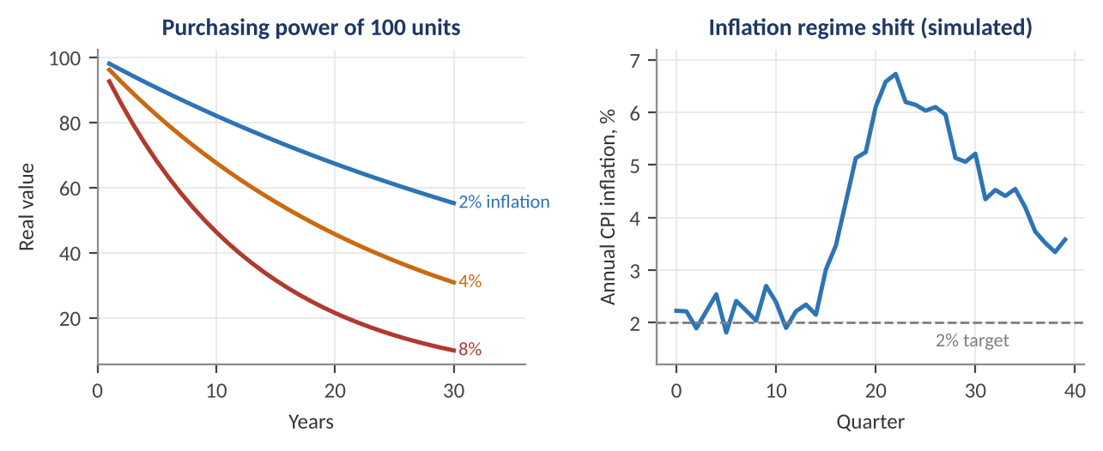
Figure 1.2 — Left: purchasing power of 100 units under constant inflation of 2%, 4% and 8%. Right: a simulated inflation series with a regime shift away from, and a partial return toward, a 2% target.
Tip — Log growth makes arithmetic additive.
Quants usually work with log growth, Δln(Y). Log growth rates add across periods (the 12-month log change is the sum of twelve monthly log changes), and the relationship becomes exactly additive: Δln(nominal) = Δln(real) + Δln(deflator). The cost is a small difference from the simple percentage at high rates; the benefit is clean time-series algebra.

1.3 The Business Cycle
Level: Beginner → Intermediate
Output does not grow smoothly. It fluctuates around a long-run trend in an irregular pattern called the business cycle: an expansion to a peak, a contraction (a recession when severe and widespread) to a trough, then a recovery. Cycles differ in length and depth, so the stylised sine wave in Figure 1.3 is a teaching device, not a forecasting tool.
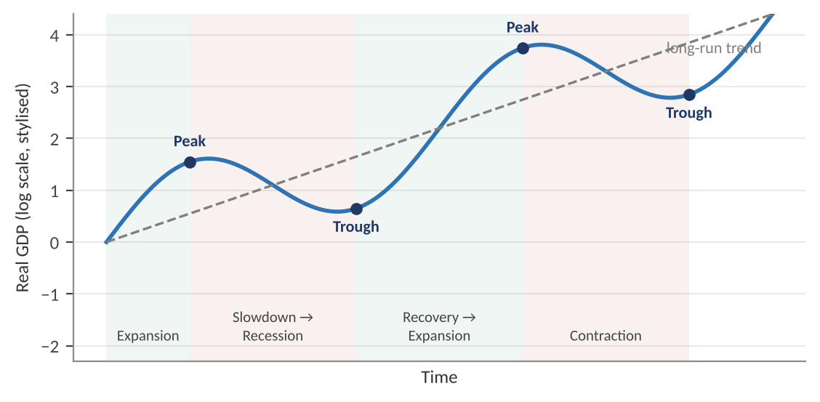
Figure 1.3 — The stylised business cycle: real output oscillates around a rising long-run trend. Turning points (peaks and troughs) are what macro investors try to anticipate; the phases drive different asset-class behaviour.
The output gap measures where the economy sits relative to its sustainable level:
Output gap = (Y − Y*) / Y* × 100
where Y* is potential output, the level consistent with stable inflation. A positive gap means resources are strained and inflationary pressure builds; a negative gap means slack and disinflationary pressure. The catch is that Y* is unobservable. It must be estimated, commonly with a statistical filter such as the Hodrick–Prescott (HP) filter, which splits a series into trend τ and cycle by solving:
minimise Σ (y_{t} − τ_{t})² + λ · Σ [(τ_{t+1} − τ_{t}) − (τ_{t} − τ_{t−1})]²
The smoothing parameter λ (conventionally 1600 for quarterly data) sets how smooth the trend is. The HP filter has a well-known end-point problem: the latest estimate of the gap is revised substantially as new data arrive, which is exactly when you need it most. Real-time output-gap estimates are therefore much noisier than the historical gaps that appear in textbooks — a theme that returns in Part 8.

Leading, coincident and lagging indicators
Analysts classify indicators by their timing relative to the cycle. Leading indicators help forecast turning points; lagging indicators confirm them.
Table 1.1 — Cycle indicators by timing (typical examples)
Timing | Indicators | Why they behave this way
Leading | Yield-curve slope, new orders, building permits, equity prices, consumer expectations, credit spreads, initial jobless claims | They reflect decisions or expectations that precede production and hiring
Coincident | Non-farm payrolls, industrial production, real personal income, retail sales | They measure current activity and define the cycle's dates
Lagging | Unemployment duration, services inflation, bank loan balances, inventory-to-sales ratios | Firms adjust hiring, prices, and credit with delay

Worked example — The Sahm rule as a recession indicator.
The Sahm rule signals the early stage of a recession when the three-month average unemployment rate rises 0.5 percentage points or more above its low of the previous 12 months. If the 12-month low of the three-month average was 3.5% and it is now 4.1%, the gap is 0.6 points ≥ 0.5, so the rule triggers. The rule is a simple, transparent, backward-looking filter: it is fast because unemployment is a coincident series, but by construction it signals after the downturn has begun, not before.

1.4 The Labour Market and Okun's Law
Level: Beginner → Intermediate
Unemployment is the most closely watched cyclical variable because it links output to inflation and to central-bank decisions. Three types are worth distinguishing: cyclical (too little demand), frictional (workers between jobs), and structural (a skills or location mismatch). The rate at which inflation neither accelerates nor decelerates is the NAIRU (non-accelerating inflation rate of unemployment), another unobservable that has to be estimated and that moves over time.
Okun's law is the empirical regularity that unemployment changes move inversely with output growth relative to trend:
Δu_{t} = −β · (g_{t} − g*)
where g is real GDP growth, g* is trend growth, and β is typically estimated between about 0.3 and 0.5 for the US. Figure 1.4 shows the relationship on simulated data.
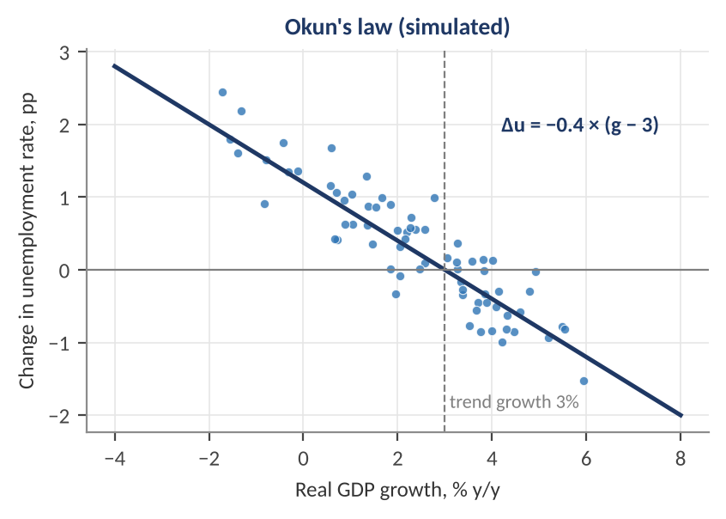
Figure 1.4 — Okun's law on simulated data with β = 0.4 and trend growth of 3%. Growth above trend lowers unemployment; growth below trend raises it. The scatter reminds us that the relation is an average, not an identity.
Worked example — Using Okun's law.
With β = 0.4 and g* = 3%, GDP growth of 1% implies Δu = −0.4 × (1 − 3) = +0.8 percentage points: unemployment rises from, say, 4.0% to 4.8% over the year. Growth of 5% implies Δu = −0.8 points. A forecaster who expects growth to slow from 3% to 1% can therefore translate the output forecast into a labour-market forecast, and from there into a view on wage growth, inflation, and the central bank's next move.

1.5 The Data Calendar: What Gets Released and When
Level: Beginner
Macro data arrive on a schedule, and the timing, frequency, and revision behaviour of each series matter as much as its content. A GDP figure for the first quarter is published weeks after the quarter ends, and then revised several times. Monthly indicators lag by one to four weeks. Surveys such as purchasing managers' indices come out within days of month-end and are never revised much, which is why markets weight them heavily despite their noise.
Table 1.2 — Key macro releases (generic pattern; exact dates differ by country)
Release | Frequency | Release lag | Revised? | What it signals
GDP | Quarterly | About 1 month (advance), then 2–3 months | Yes, repeatedly | Total activity; lagging and heavily revised
Non-farm payrolls / employment | Monthly | About 1 week after month-end | Yes, two following months, plus annual benchmark | Labour demand; a top market-mover
Unemployment rate | Monthly | Same as payrolls | Seasonal factors only | Slack; feeds Sahm rule and Okun's law
CPI / PCE inflation | Monthly | 2–4 weeks | CPI rarely; PCE yes | Price pressure; central-bank target variable
PMI / ISM surveys | Monthly | Days after month-end | Little | Timely diffusion index; above 50 means expansion
Retail sales | Monthly | About 2 weeks | Yes | Consumer demand
Industrial production | Monthly | About 2–3 weeks | Yes | Goods output; cyclical and noisy
Initial jobless claims | Weekly | Under a week | Slightly | High-frequency labour indicator
Central-bank decision and minutes | 6–8 per year (Fed: 8) | Scheduled | No | Policy rate, guidance, and the reaction function

Common mistake — Aligning data by reference date instead of release date.
A payrolls number for January is about January but is not known until early February. A backtest that uses January's figure on January 31 trades on information that did not yet exist. This look-ahead bias is the most common and most damaging error in macro backtesting, and it makes weak signals look strong. Always key each observation to the timestamp at which it became publicly available, as discussed in Part 8.

Part 2 — Inflation, Money and Central Banks
Inflation is the variable that most directly determines the policy rate, and the policy rate is the anchor for every other price in the financial system. This part covers how inflation is measured and where it comes from, how central banks respond, and how quants extract the market's expectations of what happens next.

2.1 Measuring Inflation
Level: Beginner
Inflation is the rate of change of a price index, usually measured year-on-year: π_{t} = (P_{t} / P_{t−12}) − 1. The most common index is the Consumer Price Index (CPI), which prices a fixed basket of goods and services weighted by typical household spending (a Laspeyres index):
CPI_{t} = [ Σ pᵢ,t · qᵢ,0 / Σ pᵢ,0 · qᵢ,0 ] × 100
The fixed basket means CPI overstates the cost of living when consumers substitute away from items whose prices rise. Other measures differ in scope and weighting, and central banks target specific ones.
Table 2.1 — Common inflation measures
Measure | What it captures | Notes for quants
Headline CPI | Consumer prices, all items | Includes volatile food and energy; used for inflation-linked bonds
Core CPI | CPI excluding food and energy | Smoother; better guide to persistent inflation
PCE price index | Consumer spending prices, broader and chain-weighted | The US Federal Reserve's target measure
PPI | Prices received by producers | Upstream pressure; weaker pass-through to consumers
GDP deflator | Prices of all domestic output | Quarterly; used to convert nominal to real GDP
Trimmed mean / median | Averages after dropping extreme price changes | Robust to outliers; good persistent-trend gauge
Breakevens and surveys | Market-implied and household or professional expectations | Forward-looking; matter for the Phillips curve and policy

Worked example — Weighted inflation, headline versus core.
A basket has weights food 30%, housing 40%, transport (including fuel) 20%, and other 10%. Over the year the price relatives are food +5%, housing +3%, transport +8%, other +2%. Headline inflation = 0.30×5 + 0.40×3 + 0.20×8 + 0.10×2 = 1.5 + 1.2 + 1.6 + 0.2 = 4.5%. Stripping food and transport as 'volatile' leaves housing and other, reweighted to 80% and 20%: core = 0.8×3 + 0.2×2 = 2.8%. The gap of 1.7 points between headline and core is why central banks watch both: headline drives household expectations, core is a better predictor of where inflation settles.
Two practical conversions. A three-month annualised rate from monthly changes of 0.3% is 1.003¹² − 1 = 3.66%, versus 3.6% for the simple multiple. And base effects matter: a large monthly jump twelve months ago drops out of the year-on-year figure and can cut inflation mechanically even when nothing has changed this month.

2.2 Where Inflation Comes From: Demand, Supply and Expectations
Level: Beginner → Intermediate
The aggregate demand–aggregate supply (AD–AS) model, a simple diagram relating the price level to output, organises the sources of inflation. Aggregate demand slopes downward (a higher price level reduces real wealth and raises interest rates, lowering spending). Short-run aggregate supply slopes upward (firms raise output only if prices rise relative to costs). Shifts of either curve move output and prices, as shown in Figure 2.1.
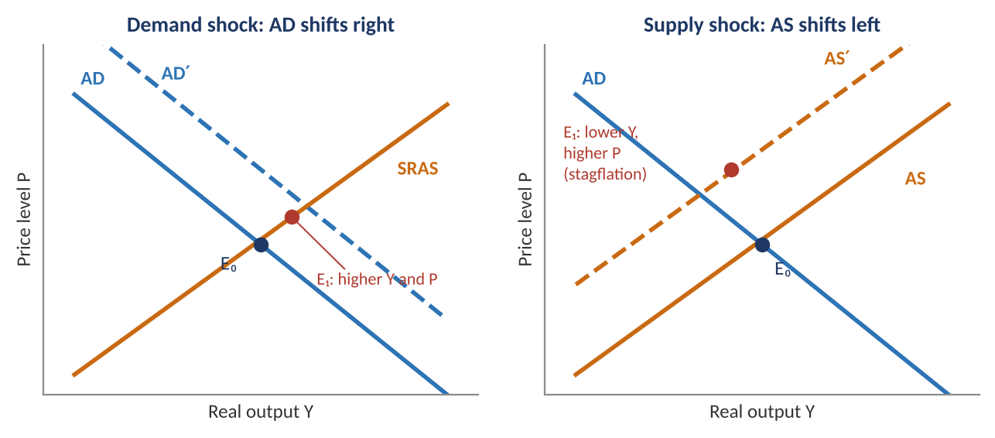
Figure 2.1 — Left: a demand shock (e.g., fiscal stimulus or easier credit) moves the economy to higher output and a higher price level. Right: an adverse supply shock (e.g., an energy-price spike) moves it to lower output and a higher price level — stagflation, the hardest case for central banks.
The distinction matters enormously for markets. Demand-driven inflation accompanies strong growth: equities may do well even as bonds suffer, and central banks tighten. Supply-driven inflation accompanies weak growth: both stocks and bonds can fall together, and the central bank faces a trade-off between its inflation and employment goals.

The Phillips curve and expectations
The Phillips curve links inflation to economic slack. The modern, expectations-augmented version is:
π_{t} = π^{e}_{t} − β · (u_{t} − u*) + ε_{t}
Inflation equals expected inflation π^{e}, minus a term proportional to the gap between unemployment u and its natural rate u*, plus supply shocks ε. The coefficient β measures the slope: how much inflation rises when the labour market tightens. Two features matter. First, if expectations are anchored (stable at the central bank's target) the curve is flat and slack matters little for inflation. If expectations drift, the whole curve shifts up and inflation persists, which is why central banks guard their credibility.
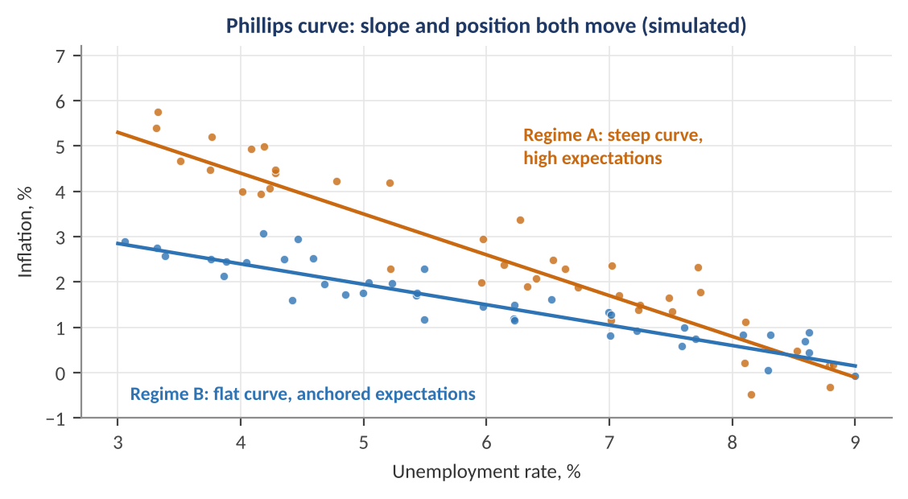
Figure 2.2 — Simulated Phillips curves in two regimes. In Regime A (high, unanchored expectations) inflation is high and responds strongly to unemployment; in Regime B (anchored expectations) the curve is lower and flatter. Both the position and the slope of the curve move over time, so a single estimated slope is unreliable.
Worked example — Applying the Phillips curve.
With expected inflation 2.0%, natural rate u* = 5.0%, β = 0.4 and no supply shock, an unemployment rate of 4.0% implies π = 2.0 − 0.4 × (4.0 − 5.0) = 2.4%. If the same tight labour market coincides with expectations rising to 3.0%, π = 3.4% — a full point higher, entirely from expectations, which is why surveys and market breakevens enter central-bank reaction functions.

Money and the quantity theory
The quantity theory of money, MV = PY, says the money supply M times its velocity V equals nominal output (the price level P times real output Y). In growth rates: m + v = π + y. In the long run, with velocity stable and output determined by real factors, inflation is a monetary phenomenon. In practice velocity is unstable over short horizons, so money growth is a poor short-run predictor, but the identity is a useful sanity check on extreme episodes.
Worked example — Quantity-theory arithmetic.
If money grows 8%, velocity falls 1%, and real output grows 3%, then π = m + v − y = 8 − 1 − 3 = 4%. If velocity collapses instead (a financial crisis), the same 8% money growth can coincide with near-zero inflation — the reason quantitative easing after 2008 did not produce the inflation a naive reading of money growth would predict.

2.3 Central Banks: Tools and Transmission
Level: Beginner → Intermediate
Central banks usually have a mandate for price stability, often combined with maximum employment (the Federal Reserve's 'dual mandate') or financial stability. They influence the economy through a handful of tools, summarised below.
Table 2.2 — The central-bank toolkit
Tool | How it works | Market effect
Policy rate (e.g., fed funds) | Sets the price of overnight interbank borrowing; steered through the interest paid on reserves and standing facilities | Anchors the front end of the yield curve and all floating-rate borrowing costs
Forward guidance | Communicates the likely future path of rates | Moves expected short rates and so intermediate yields, often before any rate change
Asset purchases (QE) / runoff (QT) | Buys or lets mature large amounts of bonds, expanding or shrinking the balance sheet | Compresses (or widens) term premia and credit spreads; affects liquidity
Reserve and liquidity facilities | Lends to banks; changes reserve requirements | Stabilises funding markets during stress
Yield-curve control / FX intervention | Targets a specific yield or exchange-rate level | Caps yields or the currency while credible; breaks if the commitment is doubted

Policy changes reach spending and inflation through several transmission channels, shown in Figure 2.3. Each operates with a lag, which is why central banks act on forecasts rather than on current inflation, and why policy rates typically affect inflation only after several quarters.
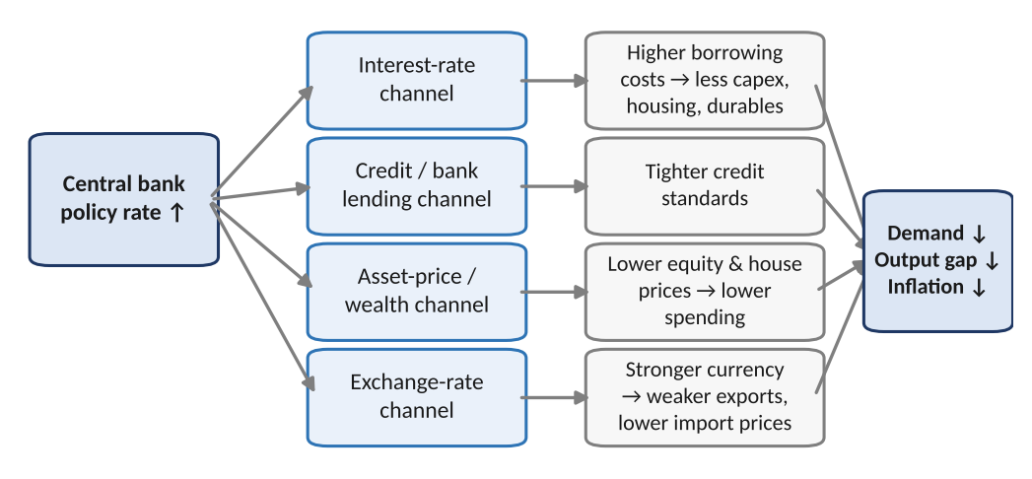
Figure 2.3 — Monetary-policy transmission. A rate rise works through the interest-rate, credit, asset-price, and exchange-rate channels to reduce demand, narrow the output gap, and lower inflation, with long and variable lags.

2.4 The Taylor Rule and Reaction Functions
Level: Intermediate
A central bank's reaction function describes how it sets rates in response to the economy. The classic summary is the Taylor rule:
i_{t} = r* + π_{t} + φ_{π} · (π_{t} − π*) + φ_{y} · (y_{t} − y*_{t})
Here i is the prescribed policy rate, r* is the neutral real rate, π is current inflation, π* is the target, and the final term is the output gap. The standard calibration has φ_{π} = φ_{y} = 0.5. The rule embeds the Taylor principle: when φ_{π} > 0 (so the total response to inflation exceeds one-for-one), a rise in inflation triggers a larger rise in the nominal rate and thus a higher real rate, which is what stabilises inflation. A rule with a total inflation response below one lets real rates fall as inflation rises and is destabilising.
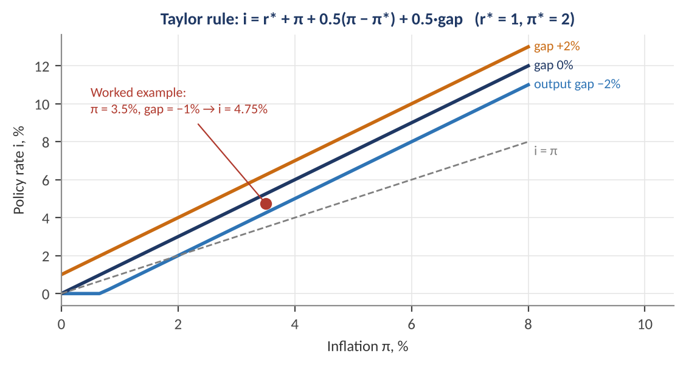
Figure 2.4 — Taylor-rule prescriptions for three output gaps (r* = 1%, π* = 2%). Each additional point of inflation raises the prescribed rate by 1.5 points; each point of output gap adds 0.5. The red dot marks the worked example below.
Worked example — The Taylor rule in practice.
With r* = 1%, inflation 3.5%, target 2%, and an output gap of −1%: i = 1.0 + 3.5 + 0.5 × (3.5 − 2.0) + 0.5 × (−1.0) = 1.0 + 3.5 + 0.75 − 0.5 = 4.75%. If the actual policy rate is 4.0%, policy is 75 basis points easier than the rule — a signal that, ceteris paribus, the central bank is behind the curve and further tightening is plausible. Quants often compute the deviation (actual − rule) as a feature, but the rule is highly sensitive to its two unobservable inputs, r* and the output gap, so different estimates of them produce prescriptions that differ by several percentage points.

Key idea — The neutral rate r* is unobservable.
The neutral real rate is the single most uncertain number in monetary policy. Estimates fall with slower trend growth, ageing, and higher desired saving, and can be extracted with state-space models (Part 7). A policy rate of 4% is 'restrictive' if r* + target inflation is 3%, and 'neutral' if it is 4%. Much of the macro-market debate about 'how tight is policy?' is really a disagreement about r*.

2.5 Reading the Market's Expectation of Policy
Level: Intermediate
Markets do not wait for a rate decision; they price it in advance. Because prices of short-rate futures and overnight index swaps (OIS) are tradable, they provide a market-implied path of policy rates, and the quantity that moves markets is the surprise relative to that path. For an interest-rate futures contract quoted as 100 minus the expected average rate:
Implied rate = 100 − futures price
Worked example — Extracting a rate-cut probability.
The current policy rate is 5.00%. A futures contract on the rate that will prevail after the next meeting trades at 95.125, implying 4.875%. If the only two outcomes are 'no change' (5.00%) and a 25 bp cut (4.75%), the market-implied cut probability p solves 5.00 − 0.25 p = 4.875, giving p = 0.125 / 0.25 = 50%. If the central bank cuts, the surprise is mild (it was a coin-flip); if it holds, the surprise is equally mild. A 25 bp move when the implied probability was 10% would be a much larger surprise and typically a much larger market reaction.

Common mistake — Treating forward rates as forecasts.
Market-implied rates are expectations plus a risk premium, so they are not unbiased forecasts. Part 3 shows how term premia contaminate forward rates, and why the forecasting record of implied rates, especially at longer horizons, is mixed.

Part 3 — Interest Rates and the Yield Curve
The yield curve is the most information-dense object in macro finance. It encodes expected policy rates, inflation expectations, and risk premia across maturities, and it is the discount-rate input to every valuation model. This part moves from the definition of real and nominal rates, through the mathematics of bond prices, to the shape and modelling of the curve and the trades built on it.

3.1 Nominal Rates, Real Rates and Inflation Compensation
Level: Beginner
A nominal interest rate is quoted in current money; a real rate is adjusted for inflation and measures the true growth in purchasing power. The Fisher equation links them:
(1 + i) = (1 + r)(1 + π^{e}) ⇒ r ≈ i − π^{e}
Worked example — Fisher equation.
A bond yields i = 4.5% and expected inflation over its life is 2.5%. Approximate real yield r ≈ 4.5 − 2.5 = 2.0%; the exact value is 1.045 / 1.025 − 1 = 1.95%. If inflation turns out to be 4.0% instead, the realised real return is 1.045 / 1.04 − 1 = 0.48%: the unexpected inflation transferred purchasing power from the lender to the borrower.

Governments issue inflation-linked bonds (such as US TIPS), whose principal adjusts with CPI. The yield on these is a market-observed real yield. The difference between a nominal yield and the real yield of the same maturity is the breakeven inflation rate:
Breakeven = y_{nominal} − y_{real} = E[π] + inflation risk premium − liquidity premium
Worked example — Breakeven inflation.
If the 10-year nominal yield is 4.3% and the 10-year real yield is 1.9%, the breakeven is 2.4%. An investor who buys the inflation-linked bond does better if average inflation over ten years exceeds 2.4% and worse if it falls below. Breakevens are not pure expectations: they include a premium for inflation uncertainty and are depressed when inflation-linked bonds are less liquid. They are nonetheless the best market-based, daily inflation-expectation measure.

3.2 Bond Mathematics: Price, Duration and Convexity
Level: Beginner → Intermediate
A bond with annual coupon C, face value F, maturity n, and yield y has price equal to the present value of its cash flows:
P = Σ_{t=1}^{n} C / (1 + y)^{t} + F / (1 + y)^{n}
Prices and yields move in opposite directions, but not linearly. The modified duration measures the first-order sensitivity and convexity the second-order curvature:
D_{mod} = −(1/P) · ∂P/∂y C = (1/P) · ∂²P/∂y²
ΔP / P ≈ −D_{mod} · Δy + ½ · C · (Δy)²
Duration is, roughly, the percentage price change for a one-percentage-point yield move: a bond with duration 8 loses about 8% if yields rise 1 point. Convexity is positive for ordinary bonds, which means price gains from falling yields exceed losses from equal rises: curvature works in the investor's favour, and investors pay for it. The more practical risk measure on a trading desk is DV01, the dollar value of a one-basis-point yield move:
DV01 = D_{mod} × P × 0.0001 (per 100 of face value)
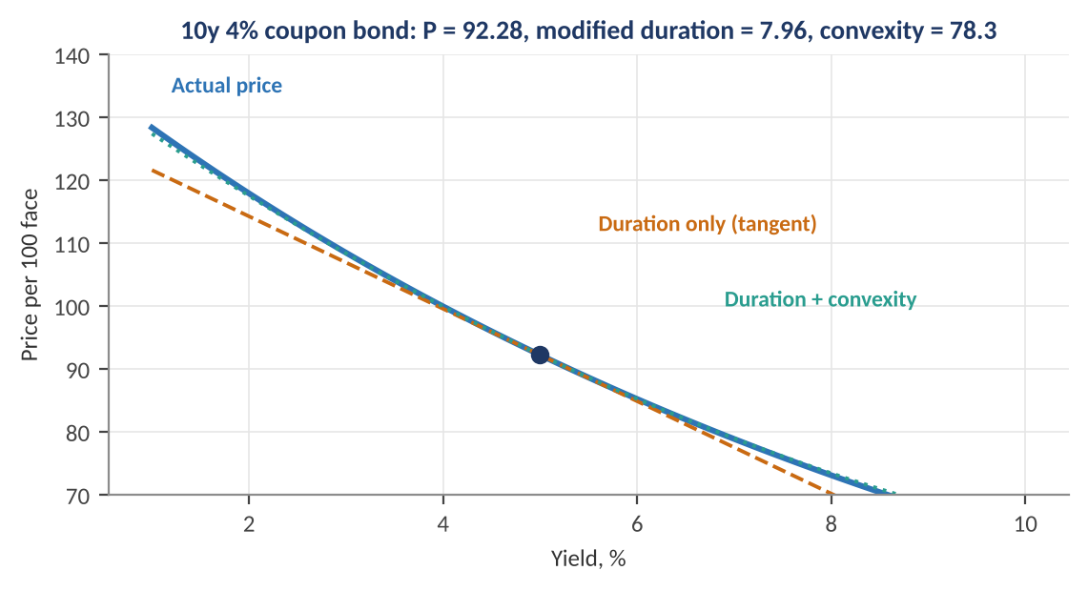
Figure 3.1 — Price–yield curve for a 10-year, 4% annual-coupon bond at a 5% yield. The straight dashed line (duration) is a good approximation near the current yield but misses the curvature; adding the convexity term nearly reproduces the exact curve.
Worked example — Duration and convexity at work.
A 10-year 4% annual-coupon bond priced at a 5% yield has price P = 92.28, modified duration 7.96 and convexity 78.3. Its DV01 is 7.96 × 92.28 × 0.0001 = 0.0735 per 100 face, so a $10m position (100,000 units of 100 face) has DV01 of about $7,350.
If yields rise 100 bp to 6%: duration alone predicts ΔP/P = −7.96%, i.e., 92.28 × (1 − 0.0796) = 84.93. Adding convexity, +½ × 78.3 × 0.01² = +0.39%, gives −7.57% and a price of 85.29. The exact price at a 6% yield is 85.28, so the two-term approximation is accurate to a cent. A 100 bp fall to 4% gives exactly par (100.00): a gain of 8.4%, larger than the 7.6% loss, which is the convexity effect.

3.3 The Yield Curve: Shapes, Forwards and the Term Premium
Level: Intermediate
The yield curve plots yields against maturity. It takes four classic shapes (Figure 3.2): normal (upward-sloping; long rates above short rates), flat, inverted (short rates above long rates), and humped. Each is associated with a different macro state: a steep curve with early-cycle recovery and easy policy; an inverted curve with tight policy and market expectations of future rate cuts.
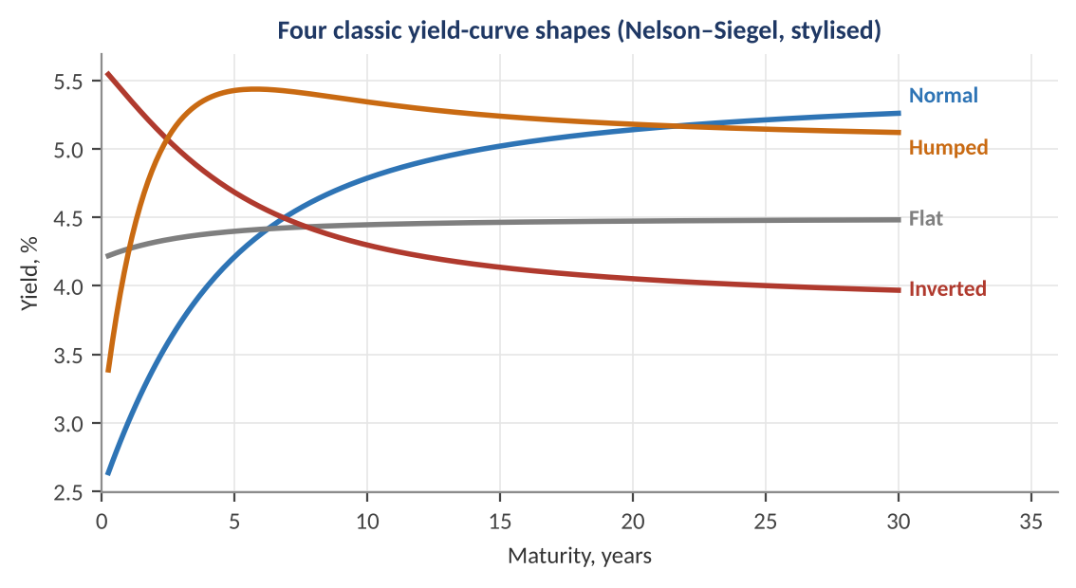
Figure 3.2 — Four classic yield-curve shapes, generated from a Nelson–Siegel model with different parameters (stylised). The inverted curve has a higher short rate than long rate, typically associated with restrictive policy and expected easing.

Forward rates
Any two points on the curve imply a forward rate — the rate for a future period that makes an investor indifferent between investing for the long period and rolling over two shorter ones:
(1 + y₂)² = (1 + y₁)(1 + f₁,₂) ⇒ f₁,₂ = (1 + y₂)² / (1 + y₁) − 1
Worked example — Computing a forward rate.
The 1-year yield is 4.0% and the 2-year yield is 4.5%. The one-year rate one year forward is (1.045)² / 1.04 − 1 = 1.092025 / 1.04 − 1 = 5.00%. Note that the forward rate is higher than either spot rate — an upward-sloping curve always implies even higher forward rates. A trader who believes the 1y rate will actually be below 5.00% in a year should lock in by buying the 2-year bond.

Expectations and the term premium
Under the expectations hypothesis, forward rates equal expected future short rates, so an n-year yield is the average of expected short rates over its life. Empirically that is incomplete. Long-term investors demand extra compensation for the risk of holding long bonds, the term premium:
y_{n} = (1/n) · Σ E[r_{t}] + TP_{n}
Worked example — Decomposing a 10-year yield.
The 10-year yield is 4.3%. A model of expected policy rates puts the average expected short rate over the next decade at 3.8%. The term premium is the residual: 4.3 − 3.8 = 0.5 percentage points. Term premia have been estimated near zero or negative during periods of heavy central-bank bond buying and strongly positive when inflation is volatile or bond supply is heavy. A rise in the 10-year yield can come from higher expected policy rates or from a rising premium, and the two have different implications for the economy and for equities.

A related theory, liquidity preference (long bonds are riskier, so they must pay more), explains why the curve is upward-sloping on average, and market segmentation / preferred-habitat theories add that pension funds and insurers have maturity preferences that can distort the curve. Quant models rarely choose one: they treat the curve as a combination of expected-rate and risk-premium components.

3.4 Modelling the Curve: Nelson–Siegel and Principal Components
Level: Intermediate → Advanced
A full curve has dozens of maturities, but its movements are highly correlated. This invites dimension reduction. The most popular parametric approach is the Nelson–Siegel model, which expresses the yield at maturity τ using three factors:
y(τ) = β₀ + β₁ · [(1 − e^{−τ/λ}) / (τ/λ)] + β₂ · [(1 − e^{−τ/λ}) / (τ/λ) − e^{−τ/λ}]
The three terms have clean interpretations (Figure 3.3). The coefficient β₀ multiplies a constant: it is the level, the long-maturity yield. β₁ multiplies a loading that starts at 1 and decays to 0: it governs the slope, since the short yield is β₀ + β₁. β₂ multiplies a hump-shaped loading: it is the curvature, which controls the medium-term bulge. The decay parameter λ sets where the hump peaks (about 3 years for λ = 1.8).
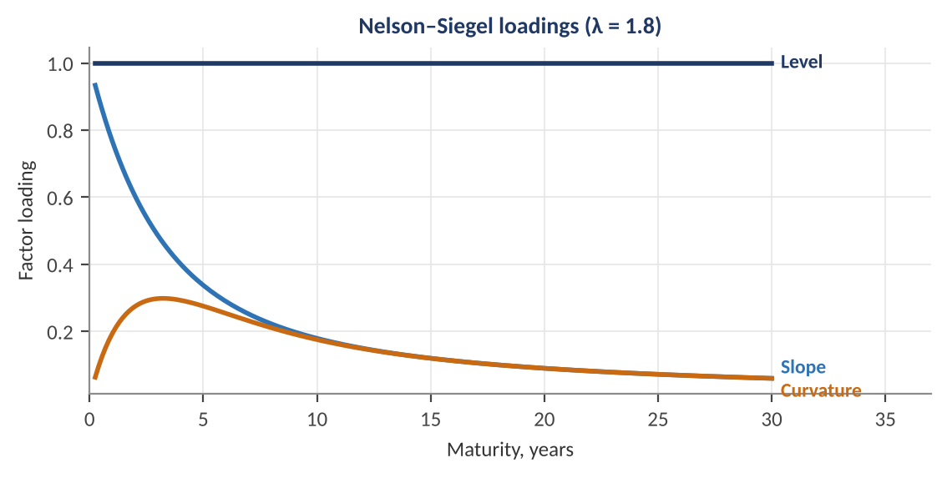
Figure 3.3 — Nelson–Siegel factor loadings with λ = 1.8. The level loading is constant across maturities; the slope loading is high at the short end and fades; the curvature loading peaks at medium maturities.
Worked example — Evaluating Nelson–Siegel.
With β₀ = 5.5, β₁ = −3.0, β₂ = −1.0 and λ = 1.8, the 2-year yield uses x = 2 / 1.8 = 1.111 and e^{−x} = 0.329. The slope loading is (1 − 0.329) / 1.111 = 0.604, and the curvature loading is 0.604 − 0.329 = 0.275. So y(2) = 5.5 + (−3.0)(0.604) + (−1.0)(0.275) = 5.5 − 1.811 − 0.275 = 3.41%. At the very short end y(0) = β₀ + β₁ = 2.5%, and at long maturities y → 5.5%: this normal curve rises 3 points from front end to back end.

An alternative is principal-component analysis (PCA) of yield changes. Across many countries and periods, the first three components of the covariance matrix of yield changes explain the great majority of variance (often over 95%) and look remarkably like the Nelson–Siegel factors: PC1 is a parallel level shift, PC2 is a slope (steepening/flattening), PC3 is a curvature (butterfly) move. The practical conclusion is that rate risk is mostly low-dimensional: hedging level, slope, and curvature exposures controls most of a rates book's risk.
Tip — Factors as state variables.
Time series of the fitted level, slope, and curvature factors are convenient state variables: they can be forecast with autoregressions (the dynamic Nelson–Siegel approach, Part 6) or related to macro variables (level tracks long-run inflation expectations, slope tracks the monetary-policy stance and cycle, curvature tracks medium-term growth expectations).

3.5 The Curve and the Cycle: Signals and Trades
Level: Intermediate
The slope of the curve, commonly measured as the 10-year minus 2-year yield (2s10s) or the 10-year minus 3-month yield, has been one of the better-known leading indicators of recession in US data, because an inverted curve usually reflects restrictive policy (high short rates) together with market expectations of eventual cuts as growth weakens. Its record is imperfect and the lead time varies from several months to over two years, so it is best treated as one probabilistic input rather than a trigger.
The curve is also the platform for relative-value trades whose profit depends on the shape, not the level, of yields. The core ones are:
- Steepener / flattener — a long position in short maturities against a short position in long maturities profits when the curve steepens, and the reverse for a flattener.
- Butterfly — long (or short) the middle of the curve against the wings, to trade curvature.
- Carry and roll-down — an upward-sloping curve lets a bond 'roll down' to a lower yield as it ages, earning price gain if the curve is unchanged.
Worked example — A DV01-neutral steepener.
Per $1m of face value, a 2-year bond has DV01 ≈ $190 and a 10-year bond ≈ $810 (illustrative). To trade a steepener without taking directional rate risk, buy $10m of 2-year bonds (DV01 = $1,900) and short enough 10-year bonds to match: 1,900 / 810 = $2.35m face (DV01 = $1,900). A parallel +10 bp move now has no net effect (−$19,000 on the long leg, +$19,000 on the short leg). If instead the 2-year yield falls 5 bp while the 10-year is unchanged, the long leg gains 5 × $1,900 = $9,500 and the short leg is flat: the position earned the steepening. Position sizing by DV01 is the basic discipline of rates trading: it converts different bonds into common risk units.

Common mistake — Equating a high yield with a high expected return.
A bond's yield is its expected return only if held to maturity without default and with reinvestment at the same yield. Over shorter horizons, return = carry + roll-down − duration × Δy + ½C(Δy)². A 5% yield with duration 8 turns into a loss over the next year if yields rise more than about 60 basis points. Always compare carry with the yield move that would exactly offset it (the breakeven yield change): here 5% / 8 = 0.625 percentage points.

Part 4 — Fiscal Policy, Aggregate Demand and Open Economies
Monetary policy is only one of two main levers. Governments also spend and tax, and every economy trades and borrows across borders, so exchange rates, capital flows, and interest-rate differentials link economies together. This part covers fiscal policy and the IS–LM framework, then moves to open-economy macro: the balance of payments, purchasing-power and interest-rate parity, and the carry trade.

4.1 Fiscal Policy, Multipliers and Debt Dynamics
Level: Beginner → Intermediate
Fiscal policy is government spending and taxation. A budget deficit adds to demand in the short run; a surplus subtracts. Because each unit of spending becomes someone's income, part of which is spent again, the total effect on output is a multiple of the initial change. In the simplest Keynesian model with marginal propensity to consume c and a proportional tax rate t:
ΔY = ΔG / [1 − c(1 − t)] (spending multiplier = 1 / [1 − c(1 − t)])
Worked example — The fiscal multiplier.
With c = 0.75 and t = 0.20, the multiplier is 1 / (1 − 0.75 × 0.80) = 1 / 0.40 = 2.5: a 100 increase in government spending raises output by 250 in this textbook model. Real-world estimates are much lower and state-dependent, commonly around 0.5 to 1.5. The textbook figure is an upper bound because it ignores crowding-out (higher interest rates deter investment), imports (spending leaks abroad), and central-bank offset (the central bank may tighten in response). Multipliers tend to be larger when interest rates are at the zero lower bound and there is spare capacity.

The IS–LM model summarises the interaction of goods and money markets. The IS curve gives combinations of interest rate and output at which planned spending equals output (downward-sloping: lower rates raise investment). The LM curve gives combinations at which money demand equals money supply (upward-sloping: higher output raises money demand and so the rate needed to clear the market).
IS: Y = A − b · r LM: M / P = k · Y − h · r
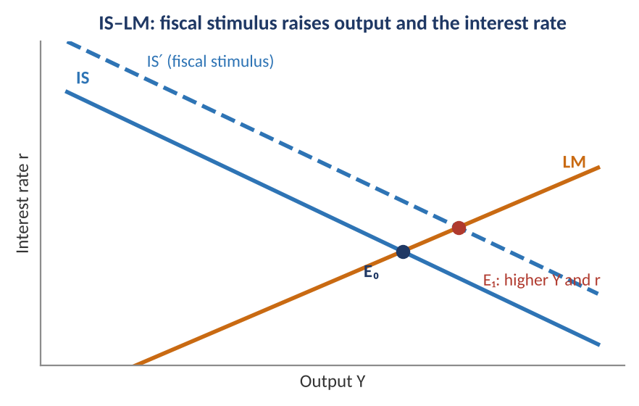
Figure 4.1 — IS–LM. A fiscal stimulus shifts the IS curve right, raising both output and the interest rate. The higher rate partially crowds out private investment, so the full multiplier is not realised.

Debt sustainability
The government's debt-to-GDP ratio b evolves according to the gap between the interest rate on debt and the growth rate, and the primary balance (the budget balance excluding interest):
Δb_{t} = [(r − g) / (1 + g)] · b_{t−1} − pb_{t}
Worked example — Stabilising the debt ratio.
Debt is 100% of GDP, the average interest rate is 4%, and nominal growth is 2%. The 'snowball' effect adds (0.04 − 0.02) / 1.02 × 100% = 1.96 percentage points of GDP to the ratio each year. To keep debt stable the government needs a primary surplus of 1.96% of GDP. If growth exceeds the interest rate (r < g), the ratio falls even with a primary deficit, which is why the r − g gap is central to debt-sustainability analysis, and why markets focus on the credibility of the fiscal path whenever yields rise faster than growth.

4.2 The Balance of Payments and Exchange Rates
Level: Beginner → Intermediate
The balance of payments records every transaction between residents and the rest of the world. It must balance: a current-account deficit (imports of goods, services, and income exceed exports) is financed by a net inflow on the capital and financial account (foreigners buying domestic assets or lending to residents):
Current account + Capital & financial account + Errors ≈ 0
A persistent current-account deficit therefore requires continuing foreign willingness to finance it, which makes the exchange rate and interest rates endogenous to capital flows. An exchange rate is the price of one currency in terms of another; the real exchange rate adjusts for price levels: q = S × P* / P, where S is domestic currency per unit of foreign currency, P* the foreign price level, and P the domestic one. A rising q means domestic goods are getting cheaper relative to foreign goods (a real depreciation).

Purchasing-power parity (PPP)
The law of one price says identical goods should cost the same everywhere when expressed in a common currency, which gives absolute PPP: S = P / P*. Quoted as the rate that equalises a basket's price, it provides a long-horizon anchor for the exchange rate, even though deviations can persist for years.
Worked example — Purchasing-power parity.
A basket costs $5.50 in the US and €4.40 in the euro area. The PPP exchange rate is 5.50 / 4.40 = 1.25 USD per EUR. If the market rate is 1.10, the euro is undervalued relative to PPP by 1.10 / 1.25 − 1 = −12%. PPP-based valuation is useful for multi-year horizons: mean reversion toward PPP is slow, with half-lives of several years, so it is a poor timing tool for months.

Covered and uncovered interest parity
Two parity conditions link exchange rates to interest-rate differentials. Writing S as domestic currency per unit of foreign currency, with domestic and foreign one-year rates i_{d} and i_{f}:
Covered interest parity (CIP): F = S · (1 + i_{d}) / (1 + i_{f})
Uncovered interest parity (UIP): E[S_{t+1}] / S_{t} = (1 + i_{d}) / (1 + i_{f})
CIP is an arbitrage relation: the forward rate F is determined by the spot rate and the interest differential, because borrowing in one currency, converting, investing, and hedging with a forward leaves no risk, so it must earn no excess profit. It holds closely (apart from small deviations, called the cross-currency basis, in funding-stressed periods). UIP instead states that the expected spot change offsets the interest differential, so an investor earns the same expected return in either currency. This is an equilibrium condition for risk-neutral investors, and it fails empirically.
Worked example — CIP and the forward premium.
Spot EURUSD is 1.1000 (USD per EUR); the USD one-year rate is 5% and the EUR rate is 3%. CIP gives F = 1.1000 × 1.05 / 1.03 = 1.1214. The euro trades at a forward premium of about 1.9% because euro rates are lower: an investor holding euros at 3% must be compensated for forgoing the extra 2% in dollars, and the forward market embeds that. A hedged investor who invests dollars in euros earns exactly the 5% dollar rate; there is no free lunch.

Why does UIP fail? The Fama regression tests it by regressing the realised currency change on the forward premium:
s_{t+1} − s_{t} = α + β · (f_{t} − s_{t}) + ε_{t+1}
UIP implies α = 0 and β = 1. The empirical estimates are typically far below 1, often negative. High-interest-rate currencies tend not to depreciate as much as the differential implies and sometimes even appreciate, so borrowing the low-yielding currency and holding the high-yielding one has historically earned a positive average return. This 'forward premium puzzle' is the empirical basis for the carry trade.

4.3 The Currency Carry Trade
Level: Intermediate
The carry trade borrows in a low-yielding (funding) currency and invests in a high-yielding one. The return per unit of notional over a period is the interest differential less the change in the exchange rate:
Carry return ≈ (i_{high} − i_{low}) − Δs
Worked example — A carry position.
Borrow JPY at 0.5% and invest in AUD at 4.5%: the carry is 4.0% a year. The trade profits if AUD/JPY falls by less than 4% over the year (the breakeven depreciation), loses if it falls by more. If AUD/JPY drops 10% while the position is on, the loss is 10 − 4 = 6% of notional before leverage.

The carry trade's profile is distinctive. Returns accrue slowly and steadily from interest income, and give up large chunks suddenly during risk-off episodes, when funding currencies appreciate rapidly as investors unwind leveraged positions. The return distribution therefore has negative skewness and fat left tails: 'picking up nickels in front of a steamroller'. Figure 4.2 simulates such a strategy.
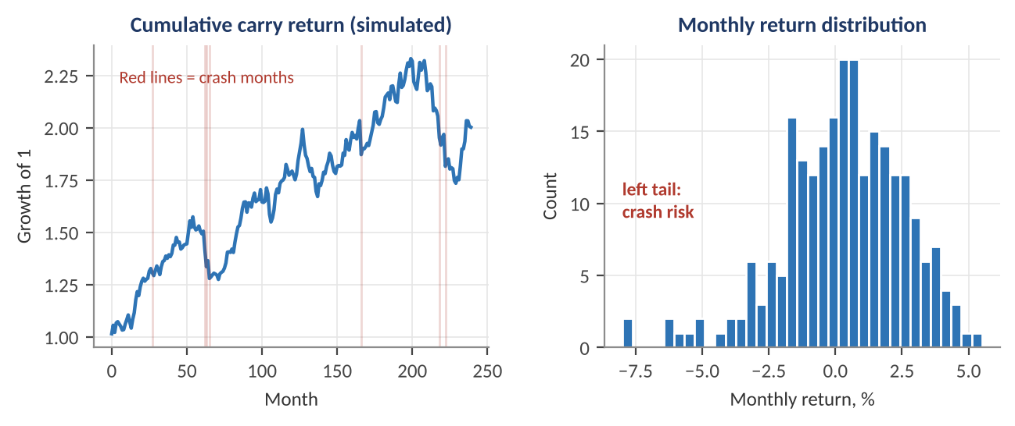
Figure 4.2 — A simulated carry strategy: steady gains punctuated by sudden crash months (red). The histogram shows the left-tail asymmetry. In this simulation the mean return is about 3.8% a year with volatility of 7.9%, a Sharpe ratio near 0.5, and skewness of −0.6.
Key idea — Carry is compensation for bearing crash risk.
The positive average return of carry is plausibly a risk premium, not an arbitrage: it compensates investors for exposure to global risk appetite and funding-liquidity shocks. Backtests that report only the Sharpe ratio overstate the attractiveness of such strategies. Always examine skewness, maximum drawdown, and performance in crisis periods, and consider hedged variants, such as combining carry with option protection or with a volatility filter.

4.4 Capital Mobility, Exchange-Rate Regimes and the Trilemma
Level: Intermediate
A country cannot simultaneously have all three of: a fixed exchange rate, free capital mobility, and an independent monetary policy. This is the impossible trinity (trilemma). With free capital flows, a central bank that wants to peg the currency must set its interest rates to match the anchor country's, surrendering independent policy; a central bank that wants independent policy must let the currency float or restrict capital movements.
Table 4.1 — Exchange-rate regimes and the trilemma
Regime | Gives up | Typical vulnerability
Floating rate, free capital | Exchange-rate stability | Currency volatility; imported inflation after depreciations
Hard peg / currency board, free capital | Independent monetary policy | Speculative attacks if the peg is doubted; no interest-rate buffer against shocks
Managed float with capital controls | Capital mobility | Controls leak; investors avoid markets with restrictions

The Mundell–Fleming model extends IS–LM to an open economy. Its central results, for perfectly mobile capital, are that under a floating exchange rate monetary policy is powerful and fiscal policy is weak (fiscal expansion raises rates, attracts capital, appreciates the currency, and crowds out net exports), while under a fixed rate the roles are reversed. These are benchmark results, modified in practice by risk premia and partial mobility.
- Terms of trade — the ratio of export to import prices. Commodity exporters' currencies (e.g., Norway, Australia, Canada) tend to co-move with commodity prices.
- Real effective exchange rate (REER) — a trade-weighted real exchange rate; a standard measure of competitiveness and a common valuation signal in currency models.
- Safe-haven currencies — currencies such as the dollar, yen, and Swiss franc often appreciate in global stress, which is the other side of carry-trade crash risk.

Part 5 — Macro and Asset Prices
Parts 1–4 described the economy. This part connects it to markets. It shows how growth, inflation, and discount rates enter valuation; how asset returns depend on the macro regime; how to build macro factor models; how to measure the market's reaction to data surprises; and why the correlation between stocks and bonds is itself a macro variable.

5.1 Valuation, Discount Rates and the Equity Risk Premium
Level: Beginner → Intermediate
The simplest link between macro variables and equity prices is the dividend discount model. If dividends grow at a constant rate g forever and investors require a return r, the Gordon growth formula gives the price:
P = D₁ / (r − g)
Macro enters through both terms. The required return r is the risk-free rate (set by monetary policy and inflation expectations) plus a risk premium; the growth rate g is bounded in the long run by nominal GDP growth. A change in either moves the price dramatically when r − g is small, because the denominator is a small number.
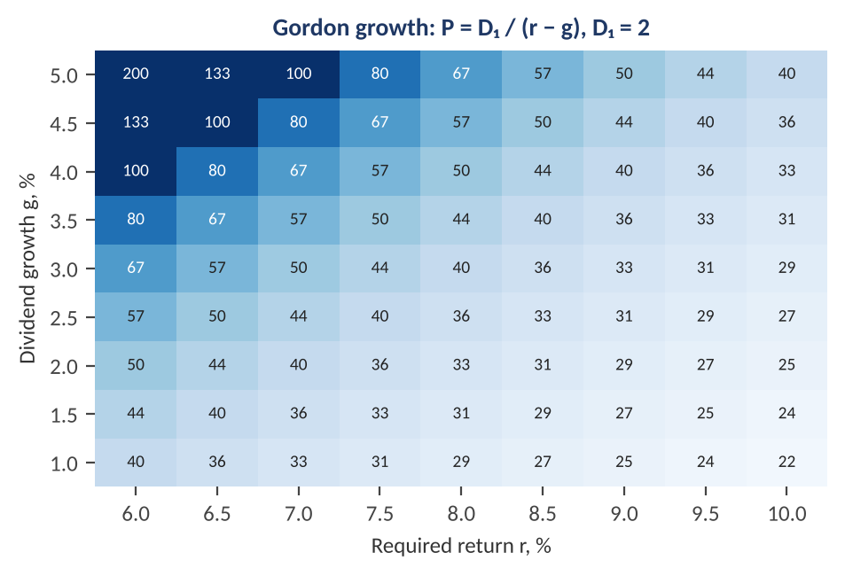
Figure 5.1 — Gordon-growth price for D₁ = 2 across required returns (columns) and growth rates (rows). Prices rise steeply as g approaches r. The same one-point move in r or in g changes the price far more when the spread r − g is narrow.
Worked example — Sensitivity of a price to macro inputs.
With D₁ = 2, r = 8% and g = 3%: P = 2 / 0.05 = 40. If monetary easing lowers the required return by 0.5 points to 7.5%: P = 2 / 0.045 = 44.4 (+11%). If the same stimulus raises long-run growth by 0.5 points to 3.5%: P = 44.4 (+11%) as well. If both happen: P = 2 / 0.04 = 50 (+25%). A stock with P / D₁ of 20 behaves like an asset with a duration of roughly 1 / (r − g) = 20 years: its price falls about 20% for a one-point rise in r − g, which is why long-duration (growth) equities are so sensitive to interest-rate surprises.

The equity risk premium (ERP) is the extra return investors expect from equities over risk-free bonds. A simple market-based proxy subtracts the real bond yield from the earnings yield (E / P):
ERP ≈ E/P − y_{real}
Worked example — A simple ERP estimate.
An index trades at a price-earnings ratio of 20, so its earnings yield is 1/20 = 5.0%. With a 10-year real yield of 1.9%, the ERP proxy is 5.0 − 1.9 = 3.1%. If the real yield rises to 3.0% while prices and earnings are unchanged, the premium shrinks to 2.0%, signalling that equities have become relatively less attractive. The proxy ignores growth in earnings (so it understates the return from growth), which is why practitioners also use dividend-discount-model-implied premia and cyclically adjusted earnings; the proxy's change over time is more informative than its level.

5.2 Growth and Inflation Regimes
Level: Intermediate
A useful way to organise macro-sensitive investing is to classify the economy by whether growth and inflation are rising or falling relative to what markets expected. That produces four regimes (Figure 5.2). Each has a characteristic winner and loser, because asset prices embed expectations and respond to the surprise component.
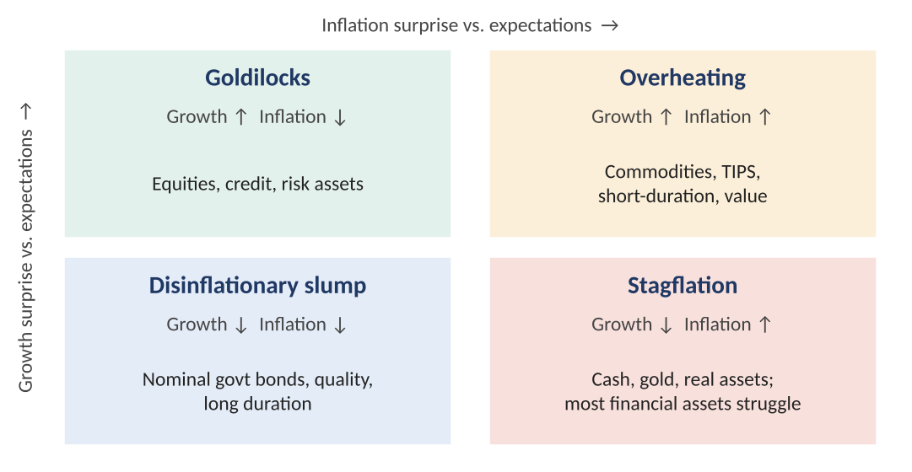
Figure 5.2 — The growth–inflation quadrant. Asset classes tend to behave differently across the four regimes, which is the foundation of 'all-weather' and risk-parity allocation: no single asset class works in every quadrant, so balance risk across them.
Table 5.1 — Stylised asset-class tendencies by regime (directional, not guaranteed)
Asset | Growth ↑ / Infl ↓ | Growth ↑ / Infl ↑ | Growth ↓ / Infl ↓ | Growth ↓ / Infl ↑
Equities | Strong | Mixed; value and energy outperform | Weak, quality and defensives hold up | Weak
Nominal government bonds | Mild gain | Lose (yields rise) | Strong (yields fall) | Lose
Inflation-linked bonds | Neutral | Gain relative to nominals | Weak relative to nominals | Gain relative to nominals
Commodities | Moderate | Strong | Weak | Strong (supply-driven)
Credit | Tightening spreads | Mixed | Widening spreads | Widening spreads
US dollar / safe havens | Mixed | Mixed | Strong | Mixed

Common mistake — Confusing levels with surprises.
Equities do not fall because inflation is high; they fall when inflation is higher than priced. A trader who goes short equities simply because inflation is elevated, when the market has already priced the path, is trading the level, not the surprise. Regime models should therefore be built on changes relative to expectations — consensus forecasts, survey data, or model-based forecasts — not on raw levels.

5.3 Macro Factor Models and Risk Premia
Level: Intermediate
Asset pricing theory says expected returns compensate for exposure to systematic sources of risk. If those sources are macroeconomic, returns can be modelled as a linear function of macro factors. The Arbitrage Pricing Theory (APT) formulation for asset i:
r_{i,t} = α_{i} + Σ_{k} β_{i,k} · F_{k,t} + ε_{i,t}
Here F_{k} are macro factors such as unexpected growth, unexpected inflation, changes in the term spread, and changes in credit spreads (the factor set of the classic Chen–Roll–Ross study), β_{i,k} is the asset's sensitivity to factor k, and ε is the idiosyncratic residual. Expected returns follow from factor risk premia: E[r_{i}] = r_{f} + Σ β_{i,k} λ_{k}, where λ_{k} is the premium per unit of exposure to factor k.
Worked example — Macro betas from a regression.
Regress the monthly return of a diversified equity portfolio on standardised surprises in growth (G) and inflation (I), using 20 years of data. A plausible result: r = 0.4% + 0.9 × G − 0.6 × I + ε, with R² = 0.30 (illustrative numbers). A one-standard-deviation positive growth surprise adds 0.9 percentage points to the return that month, and a one-standard-deviation positive inflation surprise subtracts 0.6. These betas have two uses: attribution (decomposing P&L into macro-factor contributions plus alpha) and hedging (building a portfolio with offsetting inflation exposure).

Table 5.2 — Major macro-linked risk premia
Premium | Source of return | Primary risk borne
Equity risk premium | Holding equity risk over cash | Recessions and earnings collapses
Term premium | Holding long bonds over rolling cash | Rate and inflation shocks
Credit premium | Bearing default and spread risk | Recession and liquidity stress
Inflation risk premium | Holding nominal bonds with uncertain inflation | Unexpected inflation
Currency carry | Earning interest differentials | Funding and risk-off crashes
Commodity roll yield / carry | Futures curve term structure | Supply and demand shocks

Estimating risk premia (the λ's) rather than betas is much harder. The standard method is the two-pass (Fama–MacBeth) regression: first estimate each asset's betas with time-series regressions, then run cross-sectional regressions of returns on those betas at each date and average the resulting λ estimates. Because macro factors are noisy and betas change with regimes, the estimates of λ are statistically imprecise, so treat estimated premia with scepticism.

5.4 Event Studies: Measuring the Reaction to Surprises
Level: Intermediate
Because prices already reflect expectations, only the unexpected component of a data release moves them. The standard approach measures the surprise as the actual figure minus the median forecast of economists (the consensus), scaled by the historical standard deviation of the surprise so releases are comparable across series:
z = (Actual − Consensus) / σ_{surprise}
A regression event study then relates the change in a market variable over a narrow window around the release to the standardised surprise:
Δy_{t} = α + β · z_{t} + ε_{t}
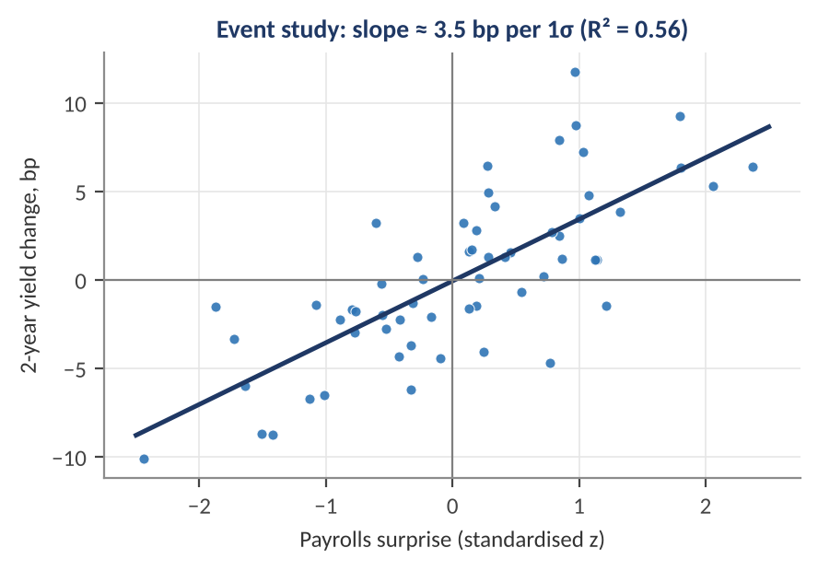
Figure 5.3 — A simulated event study: standardised payrolls surprises against the change in the 2-year Treasury yield in a short window around the release. The fitted slope of about 3.5 bp per standard deviation of surprise is typical of the order of magnitude seen in practice for important releases.
Worked example — Using the event-study slope.
Payrolls come in at 250,000 against a consensus of 180,000, with a historical surprise standard deviation of 60,000: z = (250 − 180) / 60 = +1.17. With β = 3.5 bp per standard deviation, the model predicts a 4.1 bp rise in the 2-year yield. If the move is +9 bp, the residual of about 5 bp suggests either that other news arrived (a revision, a wage figure, a Fed speaker) or that the market is in a regime in which this indicator is weighted more heavily. Reaction functions are state-dependent: the same strong number can raise yields when the central bank is hiking and lower them when markets fear overheating, and move equities in opposite directions depending on whether the 'good news is bad news' regime is in force.

- Window choice — use intraday windows (for example, 5 minutes before to 30 minutes after) to isolate the release from other news.
- Multiple simultaneous releases — payrolls, unemployment, and wages arrive together; regress on all surprises jointly.
- Consensus quality — consensus forecasts are sometimes stale or biased, and survey dispersion measures the uncertainty around the surprise.

5.5 Stock–Bond Correlation as a Macro Variable
Level: Intermediate → Advanced
The diversification benefit of bonds depends on their correlation with stocks, and that correlation is not constant. When the dominant macro shocks are to growth, stocks and bonds tend to move in opposite directions (bad growth news hurts stocks and lowers yields, raising bond prices), so the correlation is negative. When the dominant shocks are to inflation or monetary policy, both assets can fall together (higher discount rates hit both), and the correlation turns positive. The regime therefore depends on how much inflation uncertainty is in the system, as shown by the multi-decade shifts in the sign of this correlation.
For a two-asset portfolio with stock weight w, the variance depends directly on this correlation:
σ²_{p} = w² σ²_{s} + (1 − w)² σ²_{b} + 2w(1 − w) ρ σ_{s} σ_{b}
Worked example — A 60/40 portfolio under two correlation regimes.
Take w = 0.6, σ_{s} = 16% and σ_{b} = 7%. With ρ = −0.3: σ²_{p} = 0.36 × 256 + 0.16 × 49 + 2 × 0.6 × 0.4 × (−0.3) × 16 × 7 = 92.16 + 7.84 − 16.13 = 83.87, so σ_{p} = 9.16%. With ρ = +0.5: σ²_{p} = 100.0 + 26.88 = 126.88, so σ_{p} = 11.26%. Same weights, same asset volatilities, and portfolio risk is 23% higher simply because the macro regime changed the sign of the correlation. A static risk model calibrated on the first regime would understate risk in the second.

Risk parity as a response
Risk parity allocates capital so that each asset class contributes equally to portfolio risk, rather than equal capital. With uncorrelated assets, the weights are inversely proportional to volatility: w_{i} ∝ 1 / σ_{i} (the full correlated version, equal risk contribution, is covered in the Optimisation module). Because low-volatility assets such as bonds receive large weights, risk-parity portfolios typically use leverage to reach a target return or risk level.
Worked example — Inverse-volatility weights.
Three asset classes with volatilities of 16% (equities), 6% (bonds), and 15% (commodities) have inverse-volatility values of 0.0625, 0.1667, and 0.0667, summing to 0.2958. The weights are 21.1%, 56.3%, and 22.5% respectively. Most of the capital sits in bonds, though risk is equal across the three. Because the portfolio's volatility is then low, the manager may lever the whole portfolio by a factor that targets, for example, 10% volatility. The strategy's weakness is exposure to the correlation regime above: when stocks and bonds fall together (an inflation shock), the low-volatility bond holding, scaled up by leverage, suffers badly.

Part 6 — Time-Series Econometrics for Macro Data
Macro data are time series: ordered, autocorrelated, and often trending. Ordinary regression tools assume independent observations and so mislead when applied naively. This part introduces the statistical toolkit that macro quants actually use: stationarity and unit roots, autoregressive models and forecast evaluation, vector autoregressions and impulse responses, cointegration, and local projections.

6.1 Stationarity, Autoregressions and Unit Roots
Level: Intermediate
A series is (weakly) stationary if its mean, variance, and autocovariances do not depend on time. Stationarity is what lets us learn from past data, because the future then resembles the past statistically. The workhorse model is the first-order autoregression, AR(1):
x_{t} = c + φ · x_{t−1} + ε_{t}, ε_{t} ~ iid(0, σ²)
When |φ| < 1 the series is stationary with mean μ = c / (1 − φ), variance σ² / (1 − φ²), and autocorrelation at lag h equal to φʰ. A shock decays geometrically, with a half-life — the time for half the effect to vanish — equal to ln(0.5) / ln(φ). When φ = 1 the series is a random walk (it has a unit root): shocks are permanent, the variance grows without bound, and the series wanders (Figure 6.1).
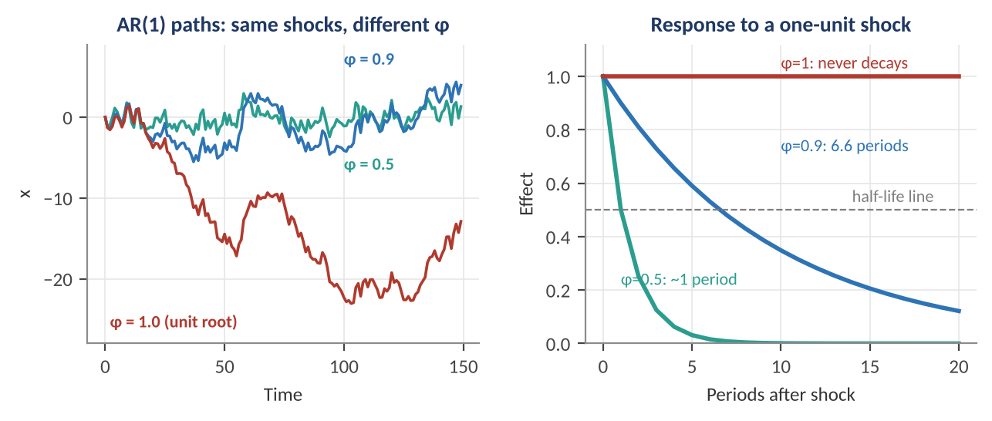
Figure 6.1 — Left: three AR(1) paths driven by the same shocks. With φ = 0.5 the series reverts almost immediately; φ = 0.9 shows persistent but mean-reverting swings; φ = 1.0 (a unit root) drifts away. Right: the effect of a one-unit shock decays at a speed determined by φ.
Worked example — Persistence and half-life.
With φ = 0.9 the half-life is ln 0.5 / ln 0.9 = −0.693 / −0.105 = 6.6 periods. If these are quarters, a shock to the output gap takes about 1.6 years to halve. The unconditional variance is σ² / (1 − 0.81) = 5.26 σ², over five times the variance of the shocks themselves, because persistent shocks accumulate. With φ = 0.5 the half-life is 1.0 period and the variance is only 1.33 σ².

Why does the unit root matter? Because regressing one trending (non-stationary) series on another can give a high R² and a significant coefficient even when the two are completely unrelated. This spurious regression problem (Granger and Newbold) is one of the most common errors in macro research. Rising GDP and rising stock prices will correlate strongly purely because both trend upward. The remedies are to test for unit roots, then either difference the data (analyse growth rates rather than levels) or use cointegration methods (6.4) when a true long-run relation exists.
The standard test is the Augmented Dickey–Fuller (ADF) test, which fits:
Δx_{t} = α + γ · x_{t−1} + Σ_{j=1}^{p} δ_{j} Δx_{t−j} + ε_{t}, H₀: γ = 0 (unit root)
Under the null the t-statistic on γ does not follow the usual t-distribution, so special critical values apply (about −2.86 at the 5% level for a regression with a constant). The KPSS test reverses the null (stationarity), so using both gives a cross-check; a series that the ADF fails to reject and the KPSS rejects is likely non-stationary. Both tests have low power against near-unit-root alternatives such as φ = 0.97, so the decision between 'very persistent' and 'unit root' often cannot be settled from the data and has to be argued on economic grounds.
Table 6.1 — Typical transformations that make macro series stationary
Series | Typical transformation | Result
GDP, price index, money stock | Log first-difference (Δln) | Growth or inflation rate
Interest rate, unemployment rate | Level (persistent) or first difference | Rate level or change
Equity index, exchange rate | Log first-difference | Return
Output | Deviation from trend (HP filter) or growth rate | Output gap or growth
Yield spread | Often kept in levels (it is stationary if rates cointegrate) | Spread

6.2 ARMA Models, Forecasting and Forecast Evaluation
Level: Intermediate
The AR(1) generalises to an AR(p) (p lags) and, with moving-average terms for shocks, an ARMA(p, q): x_{t} = c + Σ φ_{i} x_{t−i} + ε_{t} + Σ θ_{j} ε_{t−j}. The Box–Jenkins approach selects orders using the autocorrelation function and information criteria (AIC, BIC) that trade fit against parsimony; the BIC penalises complexity more heavily and usually chooses smaller models.
For an AR(1) the optimal h-step-ahead forecast pulls the current value toward the mean at geometric speed:
E_{t}[x_{t+h}] = μ + φʰ · (x_{t} − μ)
Worked example — Forecasting inflation reversion.
Inflation has mean μ = 2.0% (the target), persistence φ = 0.9 per quarter, and currently stands at 4.0%. The forecast for four quarters ahead is 2.0 + 0.9⁴ × 2.0 = 2.0 + 0.656 × 2.0 = 3.31%. At eight quarters, 2.0 + 0.43 × 2.0 = 2.86%. The model says inflation takes years to return to target, a conclusion that depends entirely on φ being close to 0.9 and on the mean staying fixed. If the true mean has itself risen (an unanchored regime), the forecast is biased downward, which is the practical danger of assuming a constant μ.

Fit is not forecast skill. Honest evaluation is out of sample, using a rolling or expanding window: estimate on data up to date t, forecast t + h, record the error, then move forward. Compare the model with a simple benchmark such as a random walk or the historical mean:
R²_{oos} = 1 − Σ e²_{model} / Σ e²_{benchmark}
A positive R²_{oos} means the model beats the benchmark. Macro and return forecasting models often struggle to achieve this, so a small positive value (such as 0.5%–2% for monthly return forecasts) can be economically meaningful, while large in-sample R² values are usually a warning sign of over-fitting. The Diebold–Mariano test tests whether the difference in forecast accuracy between two models is statistically significant.

6.3 Vector Autoregressions and Impulse Responses
Level: Intermediate → Advanced
Macro variables influence each other: growth affects inflation, inflation affects policy, and policy affects growth. A vector autoregression (VAR) models this by regressing each variable on lags of all variables. For a vector y_{t} of n variables:
y_{t} = c + A₁ y_{t−1} + A₂ y_{t−2} + … + A_{p} y_{t−p} + u_{t}, E[u_{t} u_{t}′] = Σ
The VAR is a flexible, atheoretical description of the joint dynamics. It is stable (stationary) if all eigenvalues of the companion matrix lie inside the unit circle. Three tools extract economic content: Granger causality tests whether lags of one variable improve forecasts of another (predictive, not structural, causation); forecast-error variance decomposition shows what share of each variable's forecast uncertainty comes from shocks to each variable; and impulse-response functions (IRFs) trace the dynamic effect of a one-time shock.
For a VAR(1) with coefficient matrix A, a unit shock to variable j has effect A^{h} · e_{j} after h periods (where e_{j} is a unit vector). Because the reduced-form errors u_{t} are correlated, a structural shock needs an identification assumption, such as a Cholesky ordering (some variables respond within the period, others only with a lag), which makes the results depend on the ordering.
Worked example — A two-variable growth–inflation VAR(1).
Let y_{t} = (growth_{t}, inflation_{t})′ with A = [[0.80, −0.15], [0.10, 0.70]]. Growth depends on its own lag (0.80) and negatively on lagged inflation (−0.15); inflation depends on lagged growth (+0.10) and its own lag (0.70). The eigenvalues are complex with modulus √(det A) = √0.575 = 0.758 < 1, so the system is stable. A one-unit growth shock gives y₀ = (1, 0), y₁ = A y₀ = (0.80, 0.10), y₂ = (0.625, 0.150), y₃ = (0.478, 0.168), y₄ = (0.357, 0.165): growth decays steadily while inflation builds for a few quarters, peaking near 0.17, then fades. A unit inflation shock gives growth responses of −0.15, −0.23, −0.25, −0.25, a hump with trough around −0.25 after three to four quarters: inflation shocks hurt growth with a lag.

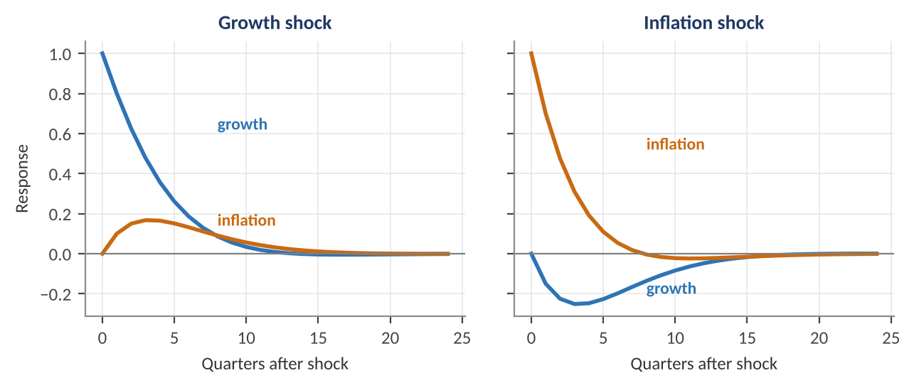
Figure 6.2 — Impulse responses for the VAR(1) in the worked example. Left: a growth shock raises inflation gradually. Right: an inflation shock lowers growth with a lag before both variables return to zero, as expected in a stable system.
- Curse of dimensionality — a VAR(p) with n variables has n²p slope parameters. With 8 variables and 4 lags that is 256 coefficients; with 300 monthly observations the estimates are noisy. Bayesian VARs with shrinkage priors (such as the Minnesota prior, which shrinks each variable toward a random walk or white noise) are the standard remedy.
- Lag selection — use information criteria, but check residual autocorrelation.
- Non-stationary data — a VAR in levels is fine for forecasting, but inference needs care; if the series are cointegrated, use a vector error-correction model (6.4).

6.4 Cointegration and Error-Correction
Level: Advanced
Two non-stationary series are cointegrated if some linear combination of them is stationary. Economically, they share a common stochastic trend and cannot drift apart without limit: a long-run equilibrium ties them together. Examples include short and long interest rates (the term spread is stationary), spot and futures prices, and the exchange rate and relative price levels (the PPP relation).
The Engle–Granger two-step method tests for a single cointegrating relation. First regress y_{t} on x_{t} in levels and take the residual z_{t} = y_{t} − β̂ x_{t}. Then test z_{t} for a unit root with an ADF test (using adjusted critical values). If the residual is stationary, the pair is cointegrated. The dynamics are then captured by an error-correction model (ECM):
Δy_{t} = α · (y_{t−1} − β x_{t−1}) + Σ γ_{i} Δy_{t−i} + Σ δ_{i} Δx_{t−i} + ε_{t}
The coefficient α < 0 measures the speed at which deviations from equilibrium are corrected. For more than two series, the Johansen test estimates the number of cointegrating relationships and is built on a vector error-correction model.
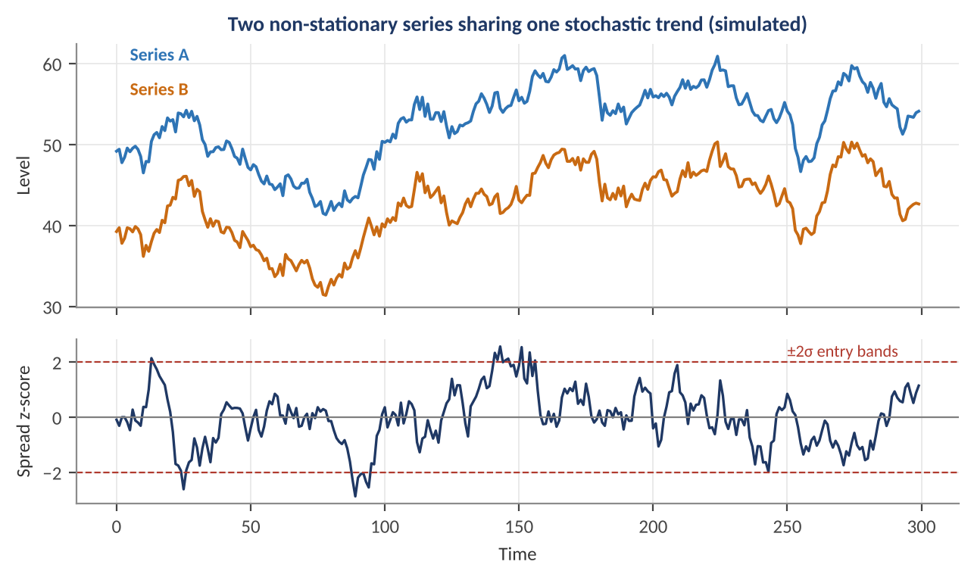
Figure 6.3 — Two simulated series that each wander like a random walk but share a common trend. The spread between them (bottom panel, standardised) is mean-reverting. Relative-value strategies trade such spreads, entering when they exceed ±2 standard deviations.
Worked example — Trading a cointegrated spread.
Suppose the spread z_{t} between two rates follows an AR(1) with φ = 0.9, so its half-life is 6.6 periods. A trader enters a position when the z-score exceeds +2 (spread is wide, bet on convergence) and exits near zero. With a half-life of 6.6 days and a typical holding of two to three half-lives, trades last roughly two to four weeks. The danger is structural breaks: if the relation permanently changes (a policy shift, a regulatory change, a change in the economy), the spread keeps diverging and the trader is on the wrong side of an apparent bargain. The cointegration estimated over a past sample is a hypothesis to monitor, not a fact.

6.5 Local Projections and Identification
Level: Advanced
An alternative to the VAR for estimating impulse responses is the local projection (Jordà), which runs a separate regression for each horizon h:
y_{t+h} = α_{h} + β_{h} · shock_{t} + γ_{h}′ controls_{t} + e_{t+h}
The coefficient β_{h} is the impulse response at horizon h. Local projections are more robust to model misspecification than a VAR, and easily accommodate non-linearities (for example, state-dependent responses in recessions versus expansions), but are less efficient (more variable) at long horizons because of overlapping observations.
The real challenge is identification: isolating a shock that is genuinely exogenous. A central-bank rate change is endogenous because the bank is responding to the economy. Practitioners use several approaches:
- Recursive (Cholesky) ordering — assume some variables respond only with a lag; simple, but assumption-dependent.
- Sign restrictions — require the responses to a shock to have plausible signs (for example, a monetary tightening raises rates and lowers prices) over a short horizon.
- High-frequency identification — use the surprise in rate futures in a tight window around policy announcements as the shock, avoiding the endogeneity problem because the window is too short for other news to matter.
- Narrative methods — read central-bank records to identify policy changes not motivated by current economic conditions.
Common mistake — Reading a VAR impulse response as causal without identification.
A reduced-form VAR describes correlations and lead-lag patterns. An 'impulse response to a rate shock' in a VAR with an arbitrary ordering may not be the response to an exogenous policy change at all. The notorious 'price puzzle' (prices rising after a rate hike in simple VARs) arises because the central bank raises rates in anticipation of inflation that the model does not observe. Before using any impulse response in a trading or risk decision, state the identification assumption and check that the results are robust to it.

Part 7 — State-Space Models, Regimes and Structural Macro
The most important macro quantities — potential output, the neutral rate, trend inflation, the current state of the economy — are unobserved. This part covers the methods for estimating them from noisy data: the Kalman filter for latent states and nowcasting, Markov-switching models for regimes, and, at awareness depth, the structural New-Keynesian model that underlies central-bank thinking.

7.1 State-Space Models and the Kalman Filter
Level: Advanced
A state-space model separates what we want to know (the latent state x_{t}) from what we observe (y_{t}). It has two equations. The state (transition) equation says how the hidden state evolves; the observation (measurement) equation says how data relate to the state:
x_{t} = F · x_{t−1} + w_{t}, w_{t} ~ N(0, Q)
y_{t} = H · x_{t} + v_{t}, v_{t} ~ N(0, R)
The Kalman filter is the optimal recursive estimator for such a linear Gaussian model. Each period it alternates two steps. Predict: project the state and its uncertainty forward. Update: when a new observation arrives, correct the prediction by a fraction of the surprise, where the fraction (the Kalman gain K) depends on the relative sizes of state uncertainty and measurement noise:
Predict: x̂_{t|t−1} = F · x̂_{t−1|t−1}, P_{t|t−1} = F · P_{t−1|t−1} · F′ + Q
Gain: K_{t} = P_{t|t−1} H′ · (H · P_{t|t−1} · H′ + R)⁻¹
Update: x̂_{t|t} = x̂_{t|t−1} + K_{t} · (y_{t} − H · x̂_{t|t−1}), P_{t|t} = (I − K_{t} H) · P_{t|t−1}
The gain has an intuitive meaning. When measurement noise R is large relative to state uncertainty P, K is small and the filter largely ignores the new data point. When R is small, K approaches 1 and the filter trusts the data. This is why a Kalman filter smooths a noisy indicator without lagging as much as a moving average: it adapts the degree of smoothing to the estimated uncertainty.
Worked example — One Kalman update.
Latent growth follows x_{t} = 0.85 x_{t−1} + 0.33 + w_{t} with state-noise standard deviation 0.35 (Q = 0.1225), and the indicator measures growth with noise standard deviation 1.1 (R = 1.21). Suppose that after the predict step the estimate is x̂ = 2.0 with variance P = 0.90. The gain is K = 0.90 / (0.90 + 1.21) = 0.43. A new reading of 3.0 is one point above the prediction, so the updated estimate is 2.0 + 0.43 × 1.0 = 2.43 and the variance drops to (1 − 0.43) × 0.90 = 0.51. The filter moved less than half-way toward the raw reading because the indicator is noisy.

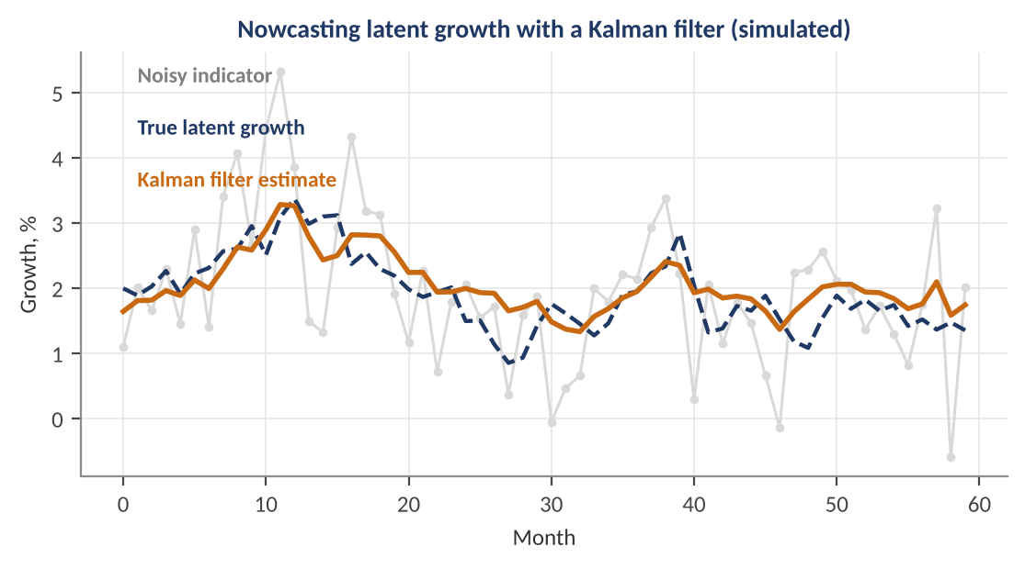
Figure 7.1 — Nowcasting latent growth with a Kalman filter on simulated data. The noisy indicator (grey) scatters widely around the true state (navy dashed); the filter estimate (orange) tracks the true state closely. In this simulation the filter's root-mean-squared error is 0.37 versus 0.98 for using the indicator directly.
State-space methods are used widely in macro-finance: estimating the time-varying neutral rate r*, trend inflation (unobserved-components models with stochastic volatility), the output gap, time-varying betas (state is the beta, evolving as a random walk), and dynamic yield-curve factors. Estimation of the parameters (F, Q, R) is by maximum likelihood, with the Kalman filter supplying the likelihood by the prediction-error decomposition.

7.2 Nowcasting
Level: Advanced
Official GDP arrives weeks after the quarter ends, but dozens of indicators (payrolls, retail sales, PMIs, industrial production, financial conditions, even card-spending and shipping data) arrive earlier. Nowcasting estimates the current quarter's GDP growth from these as they release. Public examples include the Federal Reserve Bank of Atlanta's GDPNow and the New York Fed Staff Nowcast.
The standard approach is a dynamic factor model: many indicators x_{t} are driven by a few common factors f_{t} (the 'state of the economy'), which follow a VAR, and the filter updates the estimate of f_{t} each time any indicator is released:
x_{t} = Λ · f_{t} + e_{t}, f_{t} = A · f_{t−1} + u_{t}, GDP growth_{q} = a + b′ · f
Two practical problems are central. The ragged edge: at any date, different series have different latest-observation dates, so the data matrix has missing values at the end. The Kalman filter handles this by skipping the update for missing observations. Mixed frequencies: GDP is quarterly while indicators are monthly or daily. Solutions include bridge equations (aggregate the indicators to quarterly and regress GDP on them), MIDAS regressions, or a state-space model in which GDP is observed only every third month.
Worked example — A simple bridge equation.
Regress quarterly GDP growth on the quarterly average of monthly retail-sales growth: GDP = 0.5 + 0.35 × RS, with R² = 0.40 (illustrative). After the first two months of a quarter, retail-sales growth is averaging 3.0%, so the third month is not known yet; assume it equals the average so far. The nowcast is 0.5 + 0.35 × 3.0 = 1.55%. As the third month arrives and other indicators release, the nowcast is updated. Evaluating a nowcast means testing it on real-time data (as available on each date) and watching its accuracy improve as the quarter progresses — a nowcast model that does not improve with more information is not capturing the right signal.

7.3 Markov-Switching Regime Models
Level: Advanced
Many economic and financial relationships change abruptly, between expansion and recession, or between calm and crisis markets. A Markov-switching model (Hamilton) captures this by letting the parameters depend on an unobserved discrete regime s_{t} that follows a Markov chain. For returns in two regimes:
r_{t} | s_{t} = k ~ N(μ_{k}, σ²_{k})
P(s_{t} = j | s_{t−1} = i) = p_{ij} (transition matrix P)
The transition matrix controls persistence. The expected duration of regime i is 1 / (1 − p_{ii}), and the long-run (stationary) share of time in each regime follows from the matrix.
Worked example — Durations and stationary probabilities.
Let p₁₁ = 0.95 (calm persists) and p₂₂ = 0.85 (stress persists). The expected duration of the calm regime is 1 / 0.05 = 20 months; of the stress regime 1 / 0.15 = 6.7 months. The stationary probability of the calm regime is (1 − p₂₂) / (2 − p₁₁ − p₂₂) = 0.15 / 0.20 = 75%, so the market spends a quarter of the time in the stress regime. If calm has mean return +0.9% and volatility 0.8%, and stress has mean −1.2% and volatility 2.0% (per month), the unconditional mean is 0.75 × 0.9 + 0.25 × (−1.2) = 0.375% per month.

The regime is never observed, so we infer its probability from the data with the Hamilton filter. Given the previous filtered probabilities ξ_{t−1|t−1}, form the predicted probabilities, then update with the likelihood of the new observation under each regime:
ξ_{t|t−1} = P′ · ξ_{t−1|t−1}
ξ_{t|t} = (ξ_{t|t−1} ⊙ η_{t}) / (1′ · (ξ_{t|t−1} ⊙ η_{t})), η_{t,k} = density of r_{t} under regime k
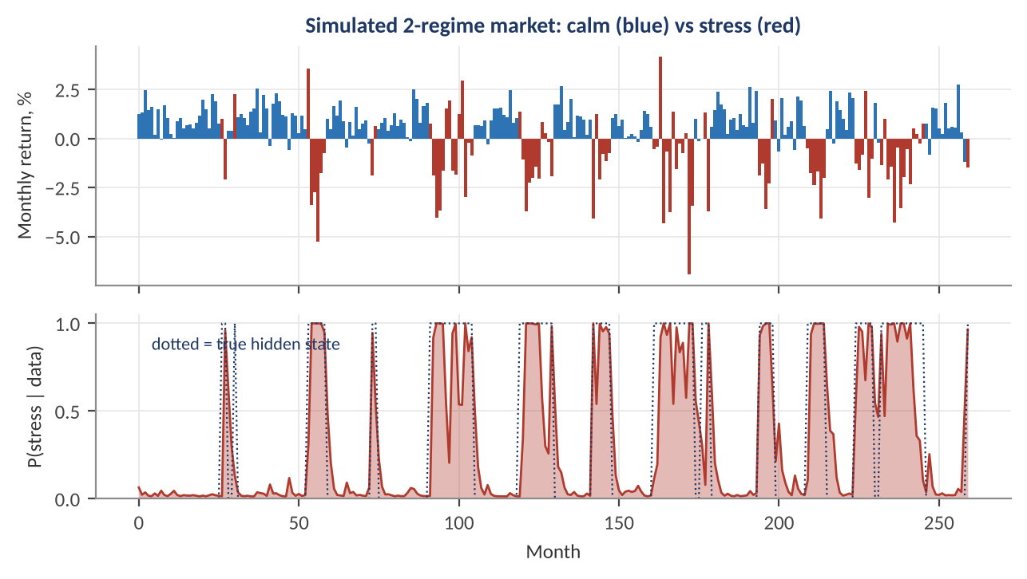
Figure 7.2 — A simulated market that switches between calm (blue) and stress (red) regimes. The bottom panel shows the filtered probability of the stress regime (shaded) against the true hidden state (dotted). The filter classifies about 90% of months correctly, but identifies stress episodes with a delay and occasionally raises false alarms.
In practice, the filtered stress probability is used as an overlay: reduce risk or leverage when the probability is high, or use regime-conditional means and covariances as inputs to the optimiser. Cautions are important. Regime detection is lagged (you learn the regime after observing some of it); regimes found in-sample may not recur; and with three or more regimes the estimation becomes fragile, with regimes that merge or flip labels. Always evaluate regime overlays out of sample and with realistic costs.

7.4 Structural Models: The New-Keynesian Framework (Awareness)
Level: Advanced
Reduced-form tools describe correlations; structural models describe the decisions of households, firms, and the central bank, which lets them answer 'what if policy changed?' questions. The core of the modern workhorse New-Keynesian (NK) model is three equations in deviations from steady state:
IS curve: x_{t} = E_{t} x_{t+1} − σ · (i_{t} − E_{t} π_{t+1}) + u_{t}
Phillips curve: π_{t} = β · E_{t} π_{t+1} + κ · x_{t}
Taylor rule: i_{t} = φ_{π} · π_{t} + φ_{x} · x_{t}
Here x is the output gap, π inflation, i the policy rate, u a demand shock, σ the sensitivity of spending to the real rate, β the discount factor, and κ the slope of the Phillips curve. The IS equation says that current output depends on expected future output and on the real interest rate. The Phillips curve says that inflation is anchored by expected inflation (a forward-looking term) plus pressure from the output gap. Together with the policy rule they pin down the dynamics.
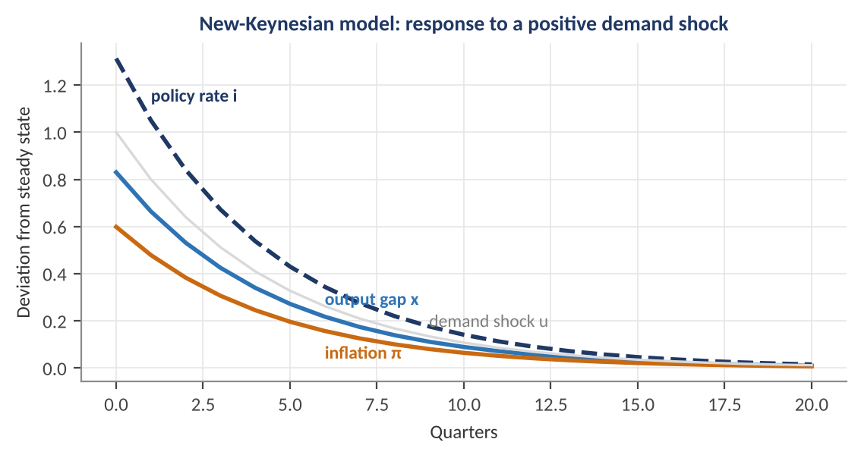
Figure 7.3 — Response to a persistent positive demand shock (autocorrelation 0.8) in the three-equation NK model with σ = 1, β = 0.99, κ = 0.15, φ_π = 1.5, φ_x = 0.5. The output gap and inflation rise; the central bank raises the policy rate by more than inflation (the Taylor principle), which holds the real rate up and gradually returns the economy to steady state.
Worked example — Solving the NK model for a demand shock.
Guess that the solution is proportional to the shock: x_{t} = a·u_{t} and π_{t} = b·u_{t}, with u_{t} following an AR(1) with coefficient ρ = 0.8. Substituting into the Phillips curve gives b = κ a / (1 − βρ) = 0.15 a / 0.208 = 0.721 a. The IS equation then gives a = 1 / [1 − ρ + σφ_{x} + σ(φ_{π} − ρ)κ / (1 − βρ)] = 1 / [0.2 + 0.5 + 0.7 × 0.721] = 1 / 1.205 = 0.83. Hence b = 0.60 and the policy-rate response is i = φ_{π} b + φ_{x} a = 1.5 × 0.60 + 0.5 × 0.83 = 1.31 per unit of shock. The interest rate rises by more than the inflation response (1.31 versus 0.60), so the real rate rises and cools demand, which is the Taylor principle at work. If the central bank were instead to respond with φ_{π} below 1, the real rate would fall as inflation rose, which can make the economy unstable.

- DSGE models (dynamic stochastic general equilibrium) extend this core with capital, wage rigidities, financial frictions, and many shocks, and are estimated by Bayesian methods. Central banks use them for scenario analysis and communication; quants use them rarely directly but benefit from the economic structure they impose.
- The Lucas critique — relationships estimated under one policy regime (such as a historical Phillips curve) may change when policy changes because people's expectations adjust. This is the intellectual reason to be wary of using reduced-form relations to evaluate big policy shifts, and a motivation for structural models.
- Limitations — representative-agent models struggle with heterogeneity, financial crises, and the zero lower bound; newer heterogeneous-agent (HANK) models address some of these but are computationally heavy.

Part 8 — From Macro Models to Macro Strategies
The previous parts built concepts and models. This final part addresses the step that decides whether any of it earns money: using macro data without fooling yourself, turning a model into a position, and understanding the major classes of macro strategy and their risks.

8.1 Real-Time Data, Revisions and Look-Ahead Bias
Level: Intermediate
Most macro series are revised after their first release: GDP is revised repeatedly, payrolls for two months and then annually, and seasonally adjusted series are re-estimated as new data accumulate. The latest version of history (the 'final' revised data in a database) is not what a trader saw at the time. A model fitted to revised data and tested on revised data reports a skill that was not available in real time.
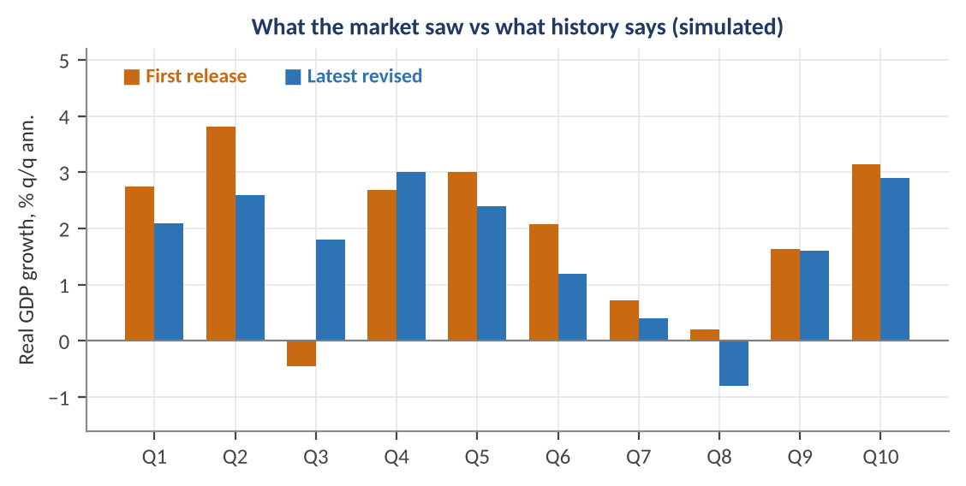
Figure 8.1 — First-release versus latest-revised growth in a simulated series. Revisions change both the level and, occasionally, the sign: in Q3 the first release shows contraction while the revised figure shows growth. A backtest on revised data would never have faced the first-release signal.
The solution is point-in-time (vintage) data: store every release of every observation with its release timestamp, and query 'what was known on date d'. Public sources include the Federal Reserve Bank of St. Louis ALFRED database and the Philadelphia Fed Real-Time Data Set; commercial vendors supply as-first-reported histories for many countries. Three timing concepts should be separated for each observation: the reference period (what the number is about), the release date (when it became public), and the vintage (which revision it is).
Common mistake — The three forms of look-ahead bias.
(1) Reference-date alignment: using January's figure on January 31 even though it was published in February. (2) Revision leakage: using a final revised number where the first release would have been available. (3) Parameter leakage: estimating a model's coefficients, seasonal factors, or filters (HP trend, regime probabilities) on the whole sample, including future data. The third is subtle: a smoothed regime probability uses future data, whereas the filtered probability uses only past data. Only the filtered version is tradable.

8.2 Why Macro Backtests Fail: A Checklist
Level: Intermediate
Table 8.1 — Common pitfalls in macro quant research
Pitfall | Symptom | Remedy
Few independent observations | A dozen recessions; t-statistics look significant because overlapping returns are treated as independent | Use HAC/Newey–West standard errors; count independent episodes; prefer cross-country or cross-asset panels
Look-ahead bias | Unreasonably high Sharpe from a slow-moving macro signal | Point-in-time data; lag all inputs by the real release lag; use filtered, not smoothed, estimates
Spurious regression | High R² and low Durbin–Watson among trending series | Test for unit roots; use changes or cointegration
Regime change / structural break | A relationship that worked for 20 years vanishes | Rolling and expanding estimation; break tests; economic rationale for the relation
Data mining | Selecting from dozens of indicators and lags until something works | Pre-specify hypotheses; adjust for multiple testing; keep an untouched hold-out period
Ignoring costs and capacity | A strategy that trades illiquid instruments at a daily frequency on monthly data | Include realistic transaction costs and turnover limits; see the Optimisation module
Over-fitting a complex model | In-sample fit far above out-of-sample | Simple models, shrinkage, cross-validation designed for time series (walk-forward)

Key idea — Overlapping observations inflate significance.
If you regress 12-month-ahead returns on a monthly signal, consecutive observations share eleven of twelve months, so there are far fewer independent data points than rows in the data. Standard OLS standard errors can be too small by a factor of three or more. With 300 monthly rows and a 12-month horizon, a rough count of independent observations is 300 / 12 = 25, which is the sample you should have in mind when judging how convincing a t-statistic of 2.5 really is.

8.3 Building a Macro Signal and Turning It into a Position
Level: Intermediate
A robust macro signal pipeline has four stages: (1) choose indicators with an economic rationale; (2) standardise them; (3) combine them into a composite; (4) map the composite into a risk-scaled position. The standardisation puts different series on a common scale using only information available at the time (an expanding or rolling window):
z_{k,t} = (x_{k,t} − μ̂_{k,t}) / σ̂_{k,t} (μ̂, σ̂ from data up to t only)
Signal_{t} = Σ_{k} w_{k} · z_{k,t} Position_{t} = (Signal_{t} clipped to [−2, 2] / 2) × (σ_{target} / σ̂_{asset,t})
Worked example — A bond signal from growth and inflation.
To decide whether to hold long-term government bonds, use z-scores of a growth surprise index (z_{g} = +1.2) and an inflation surprise index (z_{π} = −0.4). Bonds do well when growth and inflation fall, so Signal = −0.5 × z_{g} − 0.5 × z_{π} = −0.60 + 0.20 = −0.40: a mild underweight. Clip to [−2, 2] and divide by 2 to get −0.20. Targeting 10% volatility on an asset with 6% volatility, the leverage is 10 / 6 = 1.67, so the position is −0.20 × 1.67 = −0.33, i.e., a short position equal to one-third of capital in bond notional. The two ingredients of this calculation — a direction from the signal and a size from volatility — are the standard structure, and the clipping prevents a single extreme z-score from dominating.

- Signal decay and rebalancing — macro signals are slow; trading daily on a monthly signal only adds cost. Rebalance on signal changes beyond a threshold (a band) rather than every period.
- Combining signals — equal weights are surprisingly hard to beat out of sample; estimated weights should be shrunk toward equal. The Optimisation module's regularisation techniques apply directly.
- Risk and diversification — combine macro bets across countries and asset classes so that no single regime call dominates the risk.
- Performance metrics — report Sharpe ratio, maximum drawdown, hit rate, skewness, and performance by regime; with few independent observations, a deflated or bootstrapped Sharpe ratio is more honest than the raw one.

8.4 Families of Macro Strategies
Level: Intermediate → Advanced
Table 8.2 — Major macro strategy types
Strategy | Macro driver | Typical instruments | Main risk
Discretionary / systematic global macro | Growth, inflation, and policy divergence across countries | Government bonds, FX, equity indices, commodity futures | Wrong regime call; crowded positioning; policy surprises
Rates relative value / curve trading | Policy path expectations, term premium, curve shape | Government bond futures, swaps, options | Rate shocks; funding stress; basis moves
Currency carry and value | Interest differentials, PPP mispricing | FX forwards, options | Risk-off crashes; negative skew
Trend following (time-series momentum) | Slow-moving macro trends reflected in prices | Liquid futures across asset classes | Trend reversals; whipsaw in range-bound markets
Inflation trading | Inflation expectations and risk premia | Breakevens, inflation swaps, TIPS, commodities | Liquidity; model risk in seasonality and indexation
Event-driven macro | Data and central-bank surprises | Futures and options around scheduled events | Slippage, gap risk, noisy reactions
Risk parity / all-weather | Balanced exposure to growth and inflation regimes | Equities, bonds, commodities, inflation-linked bonds, with leverage | Positive stock–bond correlation; leverage in a rate shock

Understand before proceeding — Macro is a risk-taking business, not an arbitrage.
Nearly every strategy in Table 8.2 earns its return by bearing a specific macro risk: policy, inflation, funding liquidity, or crash risk. There is no free lunch, and returns arrive unevenly. The honest question to ask of any macro strategy is: which risk does this get paid for, and what happens in the regime where that risk materialises? The tools in this document — regime models, factor attribution, event studies, and robust backtesting — exist to answer that question quantitatively.

Practical Exercise
Build a point-in-time macro dashboard and a regime-aware allocation signal for one equity index and one government-bond index. Use at least 20 years of monthly data, and treat data hygiene as part of the deliverable.

Suggested approach
- Collect growth (payrolls or industrial production), inflation (core CPI), and a policy-rate or yield series. For each observation record the release date (and, if possible, first-release values), then align all series to release dates with a realistic lag.
- Transform each series to a stationary form and verify with ADF and KPSS tests. Report which series required differencing.
- Fit a VAR(2) on growth and inflation, plot the impulse responses, and state your identification assumption. Compare with local projections.
- Fit a two-regime Markov-switching model to equity returns. Plot the filtered (not smoothed) stress probability and compare it with recession dates. Compute how many months after the start of each stress episode the filter signals.
- Build an expanding-window z-score composite of growth and inflation surprises and map it into a volatility-targeted position for bonds and equities. Backtest it walk-forward including transaction costs, and compare with a 60/40 benchmark and an inverse-volatility risk-parity portfolio.
- Report Sharpe, drawdown, skewness, and the performance in each growth–inflation quadrant. Write one paragraph on which regime your strategy is exposed to and why.
Skeleton for the practical exercise (tested on synthetic data)
Replace the synthetic series with real, point-in-time data. The code requires numpy, pandas, and statsmodels.

import numpy as np, pandas as pd
from statsmodels.tsa.stattools import adfuller
from statsmodels.tsa.api import VAR
from statsmodels.tsa.regime_switching.markov_regression import MarkovRegression

# --- synthetic stand-ins for point-in-time macro data (replace with real vintages)
rng = np.random.default_rng(0)
idx = pd.period_range('1990-01', periods=360, freq='M')
growth = pd.Series(0.2 + 0.8*np.sin(np.arange(360)/18) + rng.normal(0, .6, 360), idx)
infl = pd.Series(0.2 + 0.15*growth.shift(3).fillna(0) + rng.normal(0, .3, 360), idx)
mkt = pd.Series(0.6 + 0.5*growth + rng.normal(0, 3, 360), idx) # % per month
publication_lag = 1 # months between reference month and release

# 1. Align on RELEASE date: a value is usable only once it has been published
macro = pd.concat({'growth': growth, 'infl': infl}, axis=1).shift(publication_lag)

# 2. Stationarity check
for c in macro:
p = adfuller(macro[c].dropna(), regression='c', autolag='AIC')[1]
print(f'{c}: ADF p-value = {p:.3f}')

# 3. VAR(2) and orthogonalised impulse responses (Cholesky order: growth, infl)
res = VAR(macro.dropna()).fit(2)
irf = res.irf(12)
print('Inflation response to a growth shock:', np.round(irf.orth_irfs[:5, 1, 0], 3))

# 4. Two-regime Markov-switching model for market returns
ms = MarkovRegression(mkt, k_regimes=2, switching_variance=True).fit()
hi = int(np.argmax(ms.params.filter(like='sigma2').values)) # high-variance regime
p_stress = ms.filtered_marginal_probabilities[hi] # filtered = no look-ahead

# 5. Expanding-window z-score signal -> volatility-targeted position
z = (macro['growth'] - macro['growth'].expanding(36).mean()) / macro['growth'].expanding(36).std()
signal = z.clip(-2, 2) / 2
vol = mkt.rolling(36).std() * np.sqrt(12)
position = (signal * (10 / vol)).shift(1) # trade next period: no look-ahead
strat = position / 100 * mkt
print('Annualised Sharpe:', round(float(strat.mean() / strat.std() * np.sqrt(12)), 2))

Common Beginner Mistakes
- Trading the level of a macro variable instead of the surprise relative to expectations; markets price in what is known.
- Using revised historical data and aligning by reference date rather than release date, which builds look-ahead bias into every backtest.
- Regressing non-stationary series on each other and trusting the high R², when the correlation is just two trends.
- Treating forward rates, breakevens, and futures-implied paths as forecasts and forgetting that they contain risk premia.
- Assuming a relationship estimated in one regime (the Phillips curve slope, the stock–bond correlation, a Taylor-rule fit) is a constant of nature.
- Confusing correlation or Granger causality with causation when reading VAR impulse responses without a stated identification assumption.
- Counting overlapping observations as independent and so overstating the statistical significance of slow-moving macro signals.
- Ignoring duration and convexity and treating a high yield as a high return, or forgetting that equities are long-duration assets too.
- Judging a carry strategy by its Sharpe ratio alone, ignoring skewness, drawdowns, and crash behaviour.
- Building a complex model (many-variable VAR, multi-regime model, DSGE) on a few hundred data points without shrinkage or out-of-sample testing.

Advanced Extensions
The following topics build on this document and are introduced here only by name, so you know what to look for next:
- Affine term-structure models — arbitrage-free yield-curve models (Vasicek, Cox–Ingersoll–Ross, the Gaussian ACM and Kim–Wright class) that decompose yields into expected rates and term premia with no-arbitrage restrictions.
- Bayesian VARs, factor-augmented VARs (FAVARs) and time-varying-parameter VARs with stochastic volatility — richer models of shifting macro dynamics with shrinkage for tractability.
- Mixed-frequency and machine-learning nowcasting — MIDAS, regularised regressions, random forests and neural nets on large panels of traditional and alternative data (card spending, satellite, text).
- Text and sentiment analysis of central-bank communication — quantifying hawkishness in statements and speeches as a surprise measure.
- Stochastic volatility, GARCH and macro-finance — linking macro uncertainty to time-varying volatility and risk premia.
- Heterogeneous-agent and open-economy DSGE models; sovereign-risk and currency-crisis models — structural models for scenarios and for emerging-market and fiscal-stress analysis.
- Black–Litterman with macro views — combining market-implied equilibrium returns with scenario-based macro views in a Bayesian portfolio framework (see the Optimisation module).
- Stress testing and scenario analysis — translating macro scenarios (recession, inflation spike, rate shock) into portfolio P&L through factor sensitivities.

Professional Applications
- Global macro and multi-asset investing — forming views on growth, inflation, and policy across countries, and expressing them through bonds, currencies, equities, and commodities.
- Fixed-income and rates trading — position-sizing by DV01, curve trades, and pricing of policy-path surprises around central-bank meetings.
- Asset allocation and risk budgeting — setting strategic and tactical allocations conditional on regime, and measuring risk through macro factor exposures.
- Risk management and stress testing — translating macro scenarios into portfolio losses and setting limits using regime-conditional volatilities and correlations.
- Central bank, treasury, and sovereign-wealth work — nowcasting, reaction-function modelling, debt-sustainability analysis, and reserve management.
- Systematic strategy research — building and validating macro factors, regime overlays, and event-driven signals that are robust, point-in-time, and economically motivated.

Where to Go Next
This document aimed to be a complete route from the definition of GDP to state-space and regime models, and it deliberately stopped at awareness depth for the structural and affine term-structure models listed under Advanced Extensions. The natural next steps depend on your direction. For portfolio construction, the Optimisation module shows how regime-dependent expected returns and covariances feed a mean-variance, risk-parity, or robust optimiser. For risk, the Risk Metrics module builds on duration, DV01, and regime-conditional volatility. For implementation, the data-engineering topics in Part 8 (vintage storage, release calendars, reproducible walk-forward backtests) are where many macro research projects succeed or fail.
The most valuable habit to build is to ask, for every macro model or signal: what is the economic mechanism, what data would have been available at the time, how many independent episodes support it, and what happens in the regime where it breaks?

Appendix A — Formula Sheet
Table A.1 — Key formulas by topic
Topic | Formula | Where used
GDP identity | Y = C + I + G + (X − M) | 1.1
Growth accounting | g_{Y} = α g_{K} + (1−α) g_{L} + g_{A} | 1.1
Nominal to real growth | (1 + n) = (1 + r)(1 + π) | 1.2
Output gap | (Y − Y*) / Y* × 100 | 1.3
Okun's law | Δu = −β (g − g*) | 1.4
Expectations-augmented Phillips curve | π = π^{e} − β (u − u*) + ε | 2.2
Quantity theory | m + v = π + y | 2.2
Taylor rule | i = r* + π + φπ (π − π) + φy (y − y) | 2.4
Fisher equation | (1 + i) = (1 + r)(1 + π^{e}) | 3.1
Bond price | P = Σ C/(1+y)^{t} + F/(1+y)^{n} | 3.2
Duration / convexity approximation | ΔP/P ≈ −D Δy + ½ C (Δy)² | 3.2
DV01 | D × P × 0.0001 | 3.2
Forward rate | f₁,₂ = (1+y₂)² / (1+y₁) − 1 | 3.3
Nelson–Siegel | β₀ + β₁ (1−e^{−τ/λ})/(τ/λ) + β₂[(1−e^{−τ/λ})/(τ/λ) − e^{−τ/λ}] | 3.4
Spending multiplier | 1 / [1 − c(1−t)] | 4.1
Debt dynamics | Δb = [(r−g)/(1+g)] b₋₁ − pb | 4.1
Covered interest parity | F = S (1 + i_{d}) / (1 + i_{f}) | 4.2
Gordon growth | P = D₁ / (r − g) | 5.1
APT factor model | r_{i} = α_{i} + Σ β_{i,k} F_{k} + ε_{i} | 5.3
Standardised surprise | z = (Actual − Consensus) / σ_{surprise} | 5.4
AR(1) | x_{t} = c + φ x_{t−1} + ε; half-life = ln 0.5 / ln φ | 6.1
VAR(1) impulse response | IRF_{h} = A^{h} · shock | 6.3
Error-correction model | Δy = α (y₋₁ − β x₋₁) + … | 6.4
Kalman gain | K = P H′ (H P H′ + R)⁻¹ | 7.1
Markov regime duration | 1 / (1 − p_{ii}) | 7.3
NK IS / Phillips / policy rule | x = E x′ − σ(i − Eπ′) + u; π = β Eπ′ + κ x; i = φπ π + φx x | 7.4

Appendix B — Self-Check Questions
Try these without looking back, then check against the sections noted. Answers follow the worked examples in the text.
- An economy has C = 12, I = 3, G = 3, X = 2 and M = 2.5. What is GDP, and what share is consumption? (Answer: 17.5; 68.6%. Section 1.1.)
- Nominal GDP grows 6% and the deflator rises 3.5%. What is exact real growth? (Answer: 1.06 / 1.035 − 1 = 2.42%. Section 1.2.)
- Using Okun's law with β = 0.4 and trend growth 3%, what is the change in unemployment if growth is 0%? (Answer: +1.2 points. Section 1.4.)
- Compute the Taylor-rule rate for r* = 1%, π = 4%, π* = 2%, output gap = +1%, φ = 0.5 each. (Answer: 1 + 4 + 1 + 0.5 = 6.5%. Section 2.4.)
- A 2-year yield is 3.0% and a 1-year yield is 2.5%. What is the 1-year forward rate one year ahead? (Answer: 1.03² / 1.025 − 1 = 3.50%. Section 3.3.)
- A bond has modified duration 6 and convexity 50, and yields rise 50 bp. Estimate the price change. (Answer: −6 × 0.005 + ½ × 50 × 0.005² = −3.0% + 0.06% = −2.94%. Section 3.2.)
- Spot USD per EUR is 1.20, with a USD rate of 4% and a EUR rate of 2%. What is the 1-year forward rate under CIP? (Answer: 1.20 × 1.04 / 1.02 = 1.2235. Section 4.2.)
- D₁ = 3, r = 9% and g = 4%. What is the Gordon price, and what happens if r falls to 8%? (Answer: 60, then 75, a 25% rise. Section 5.1.)
- An AR(1) has φ = 0.8. What is its half-life? (Answer: ln 0.5 / ln 0.8 = 3.1 periods. Section 6.1.)
- Why can regressing one trending series on another produce a high R² with no real relationship, and how do you fix it? (Answer: spurious regression due to common trends; test for unit roots, use differences or cointegration. Section 6.1.)
- A regime model has p₁₁ = 0.90 and p₂₂ = 0.70. What are the expected durations and the stationary probability of regime 1? (Answer: 10 and 3.3 periods; (1 − 0.70) / (2 − 0.90 − 0.70) = 0.30 / 0.40 = 75%. Section 7.3.)
- Name three forms of look-ahead bias in macro backtests. (Answer: reference-date alignment, revision leakage, parameter leakage or using smoothed estimates. Section 8.1.)

